Adversarial Machine Learning Attacks

***Objective:***

To implement “Adversarial Examples for Semantic Segmentation and Object Detection” and “DAPAS : Denoising Autoencoder to Prevent Adversarial attack in Semantic Segmentation” research papers and analyzing results from both implementations.

***DataSet:***

PASCAL VOC (<https://www.kaggle.com/huanghanchina/pascal-voc-2012>)

This dataset provides standard image data sets for object class recognition.

***Research Papers:***

1. Adversarial Examples for Semantic Segmentation and Object Detection

2. DAPAS : Denoising Autoencoder to Prevent Adversarial attack in Semantic Segmentation

***Introduction:***

Adversarial machine learning is a machine learning technique that attempts to fool models by supplying deceptive input. The most common reason is to cause a malfunction in a machine learning model. Most machine learning techniques were designed to work on specific problem sets in which the training and test data are generated from the same statistical distribution (IID). When those models are applied to the real world, adversaries may supply data that violates that statistical assumption. This data may be arranged to exploit specific vulnerabilities and compromise the results.

Machine learning has advanced in all possible fields and is now growing vastly in security, health and finance domain. Security and privacy need to be improvised in ML. So, we learn about the system i.e being affected, Frontier i.e being approached with adversary to tweak the optimality for desired outputs.

An **Adversarial attack** is also classified by the actions and information the adversary has at their disposal.

These attacks can be classified into

WHITE BOX - information about the model parameters or its original training data. They have varying degrees of accessing the model as well as its parameters. The stronger the threat model is devastating the attacks would be.

BLACK BOX - no knowledge about the model. The adversaries do not know the model internals. However, the black box threats are more realistic threat models as all it needs is the output responses to assume the model and parameters based on how it responds to the events.

Untargeted Attack - is a source class misclassification attack, which aims to misclassify the input by adding adversarial perturbation so that the predicted class of the input is changed to some other classes without a specific target class.

Targeted Attack - is a source-target misclassification, which aims to misclassify the predicted class of an example input x to a targeted class in Y by purposely crafting the input example x via adversarial perturbation. As a result, the predicted class of the input x is covertly changed from the original class (source) to the specific target class intended by the attacker.

In adversarial attacks, the following 2 steps are taken:

* The query input is changed from the benign input x to x’.
* An attack goal is set such that the prediction outcome, H(x) is no longer y. The loss is changed from l(H(x ᵢ), y ᵢ) to l(H(x ᵢ), y’ ᵢ) where y’ ᵢ ≠ y ᵢ.

**Adversarial Perturbation:**

An "adversarial perturbation" is a change to a physical object that is deliberately designed to fool a machine-learning system into mistaking it for something else. The query input is changed from x to x’ using adversarial perturbation.

***Methods:***

Semantic segmentation - Semantic segmentation, or image segmentation, is the task of clustering parts of an image together which belong to the same object class. It is a form of pixel-level prediction because each pixel in an image is classified according to a category.

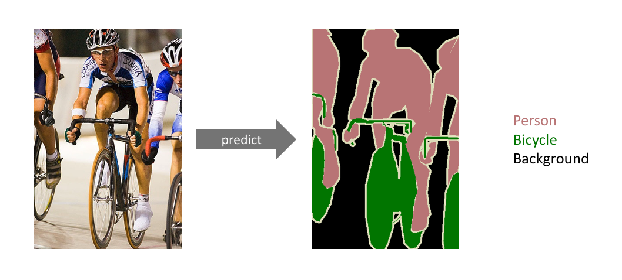

Object detection - Object detection is a computer technology related to computer vision and image processing that deals with detecting instances of semantic objects of a certain class in digital images and videos.



Region Based Convolutional Neural Networks (R-CNN) : R-CNN uses an object proposal algorithm called Selective Search which reduces the number of bounding boxes that are fed to the classifier to close to 2000 region proposals. Selective search uses local cues like texture, intensity, color and/or a measure of insideness etc., to generate all the possible locations of the object. Now, we can feed these boxes to our CNN based classifier.

Fast Gradient Sign Attack (FGSM) - It is designed to attack neural networks by leveraging the way they learn, gradients. The idea is simple, rather than working to minimize the loss by adjusting the weights based on the backpropagated gradients, the attack adjusts the input data to maximize the loss based on the same backpropagated gradients.

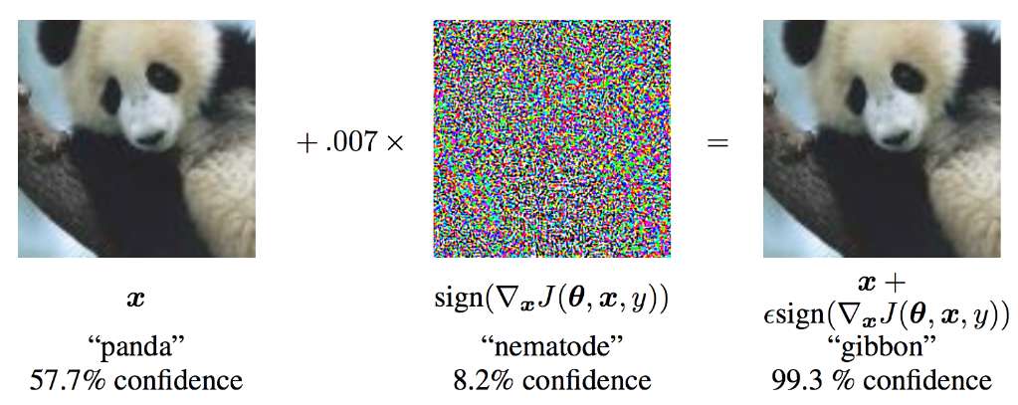

Dense Advisory Generation (DAG): It is a simple algorithm for Adversarial example generation, which considers all the targets simultaneously and optimizes the overall loss function. The implementation of DAG involves specifying an adversarial label for each target and performing iterative gradient back-propagation.

Denoising Autoencoder to Prevent Adversarial attack in Semantic Segmentation (DAPAS):

DAPAS is a defense mechanism applied in front of a model against adversarial attacks. It is a denoise autoencoder to prevent an adversarial attack in semantic segmentation that effectively removes adversarial perturbation. Since semantic segmentation involves the classification of pixels, it is important to restore the original image at the pixel level so that the restored image gives the correct semantic segmentation result. We use random noise that follows a particular distribution like Gaussian distribution, Uniform distribution, and Bimodal distribution.

**Process:**

1. Importing Libraries

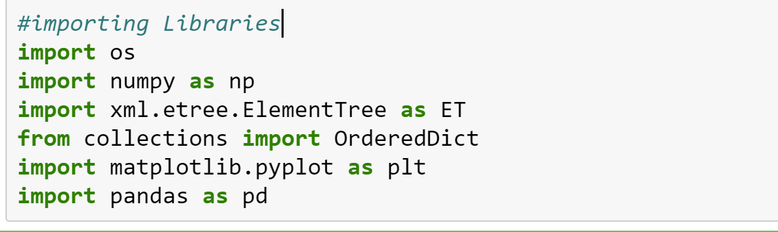

2. Loading dataset and displaying data

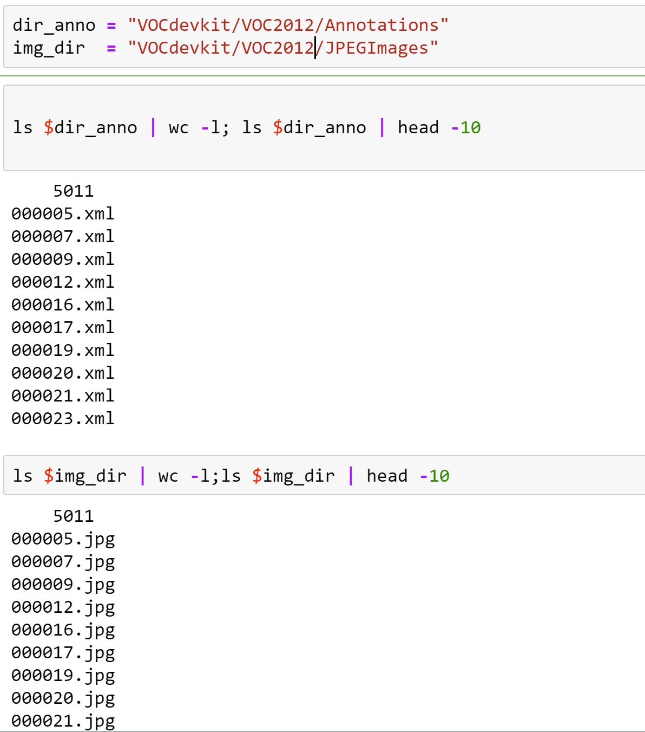

3. Extracting details from xml file

For each image we have a xml annotation file which contain details of the image like dimensions, object class, boundary box etc.,

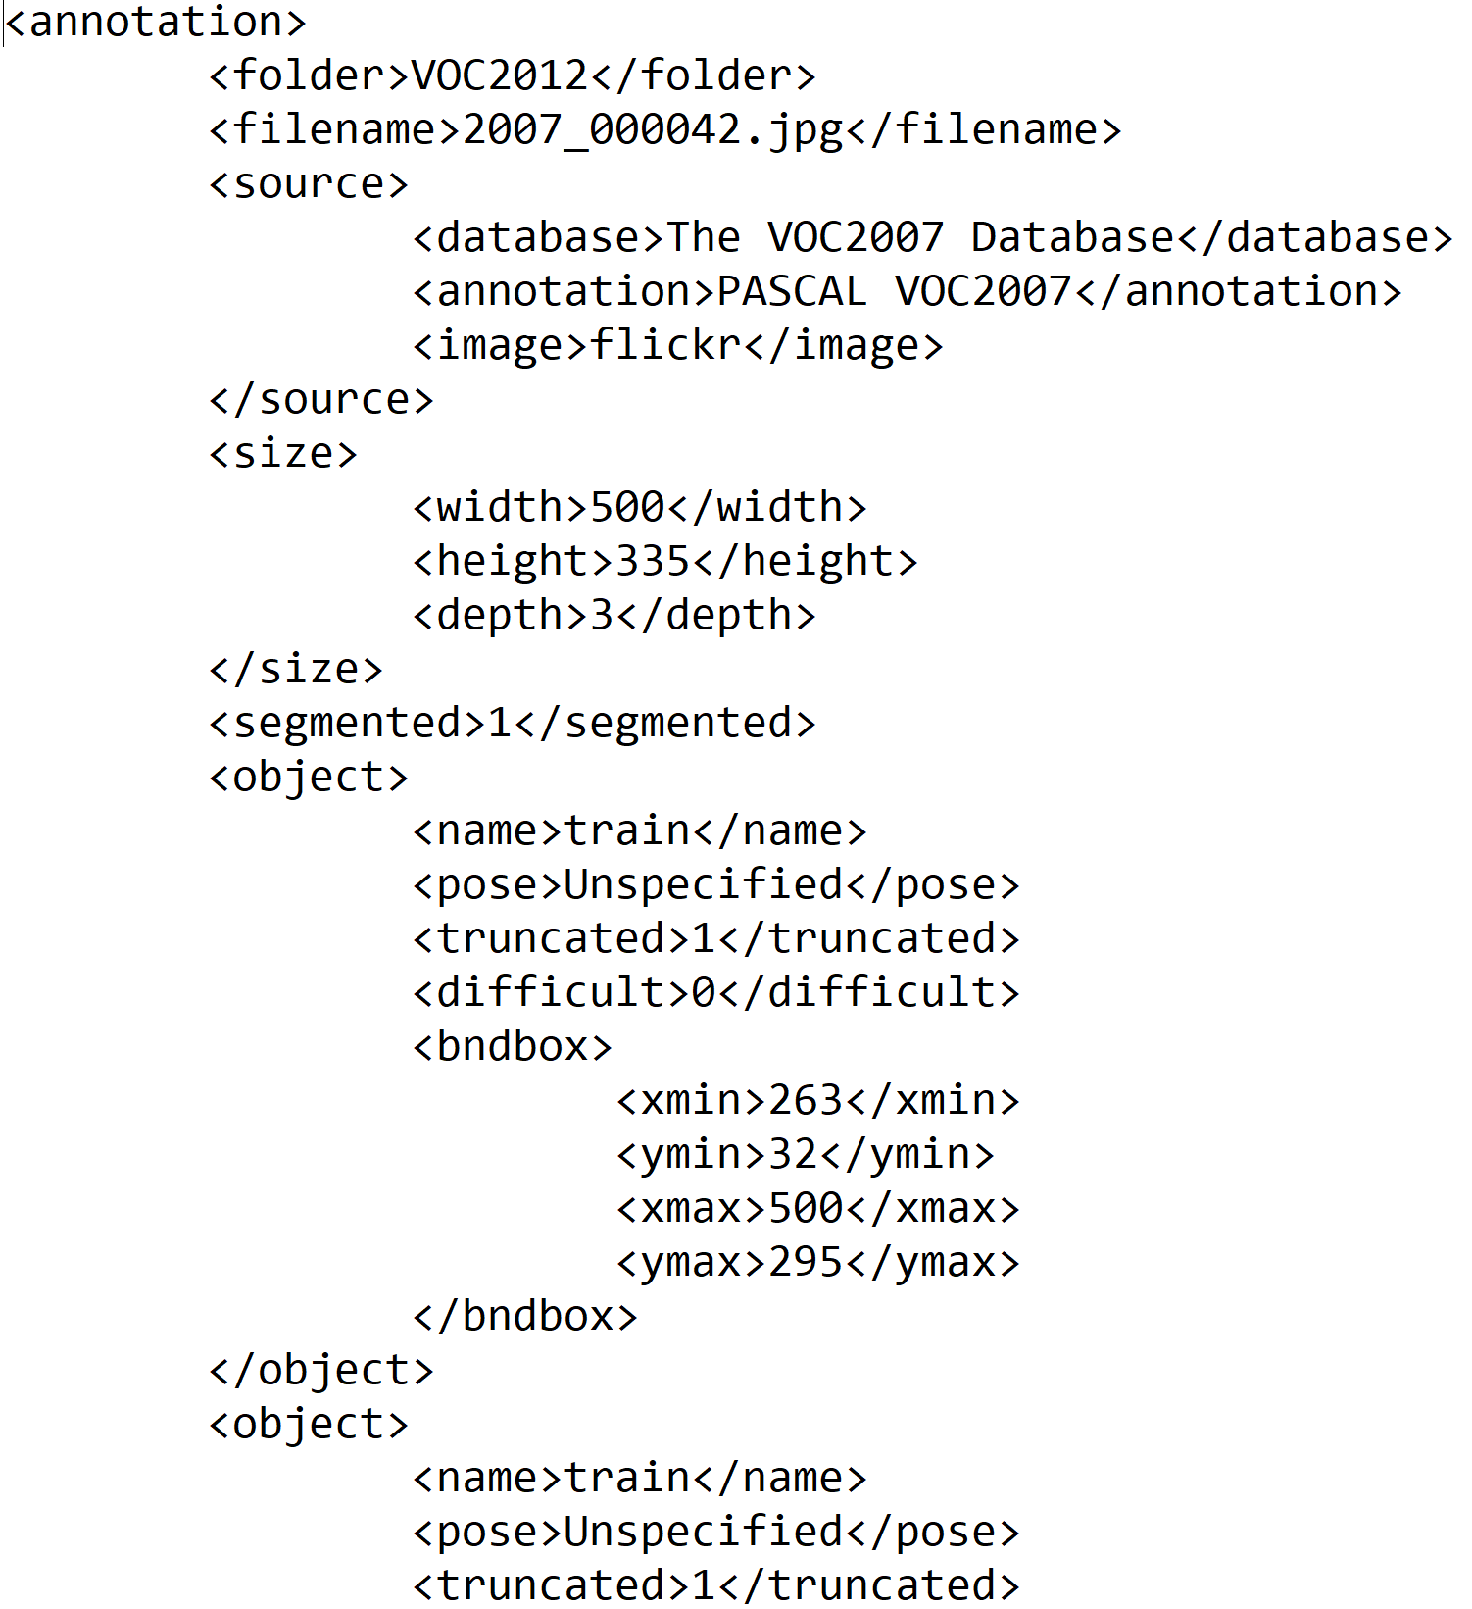

We first aggregate all these xml files into a single csv file using panda modules.

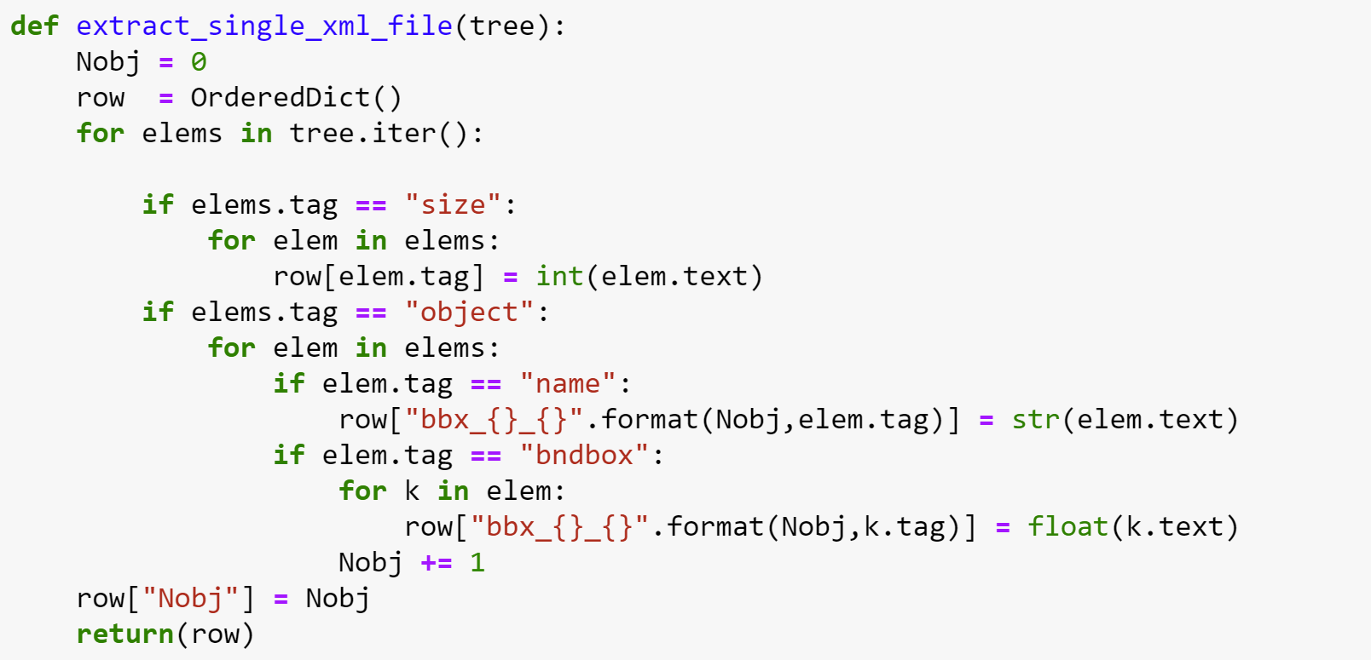

Creating pandas dataframe

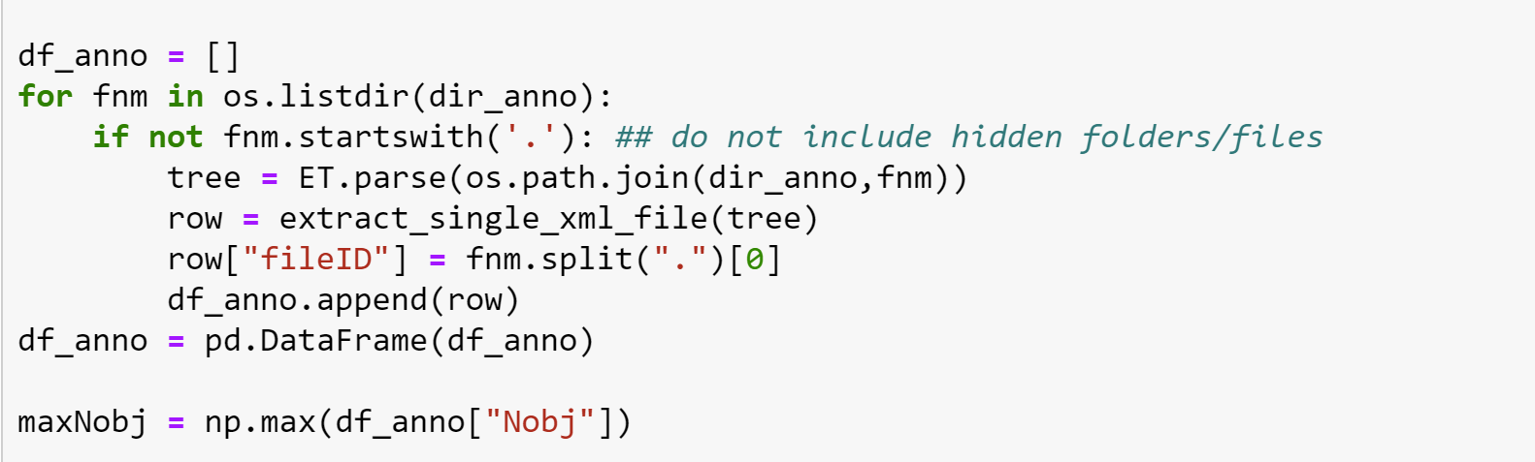

Dataframe

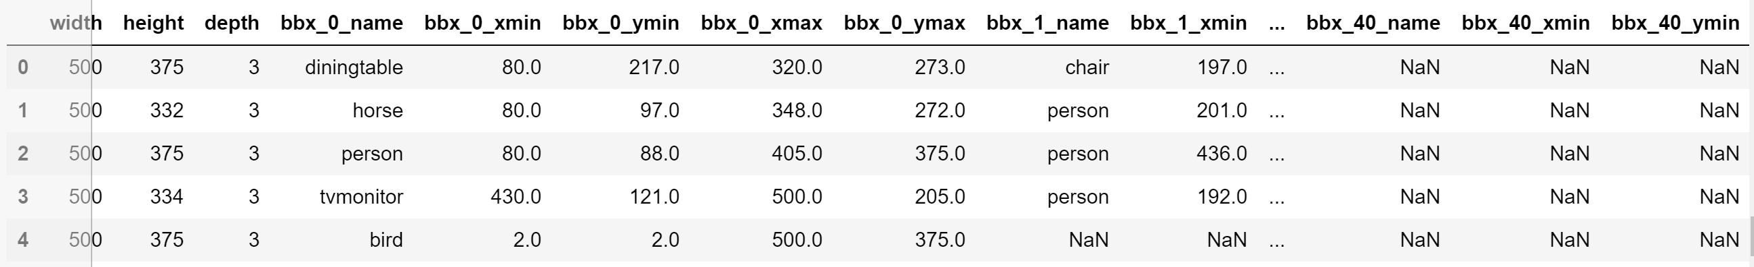

Store this data frame as csv file

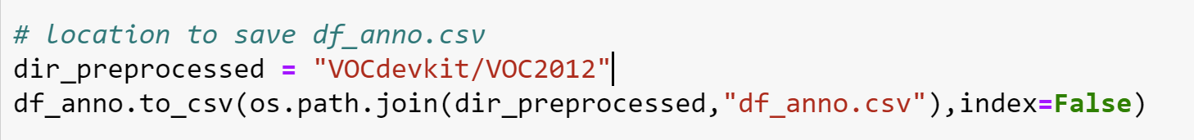

4. Visualization:

Plot to show the number of objects in each image.

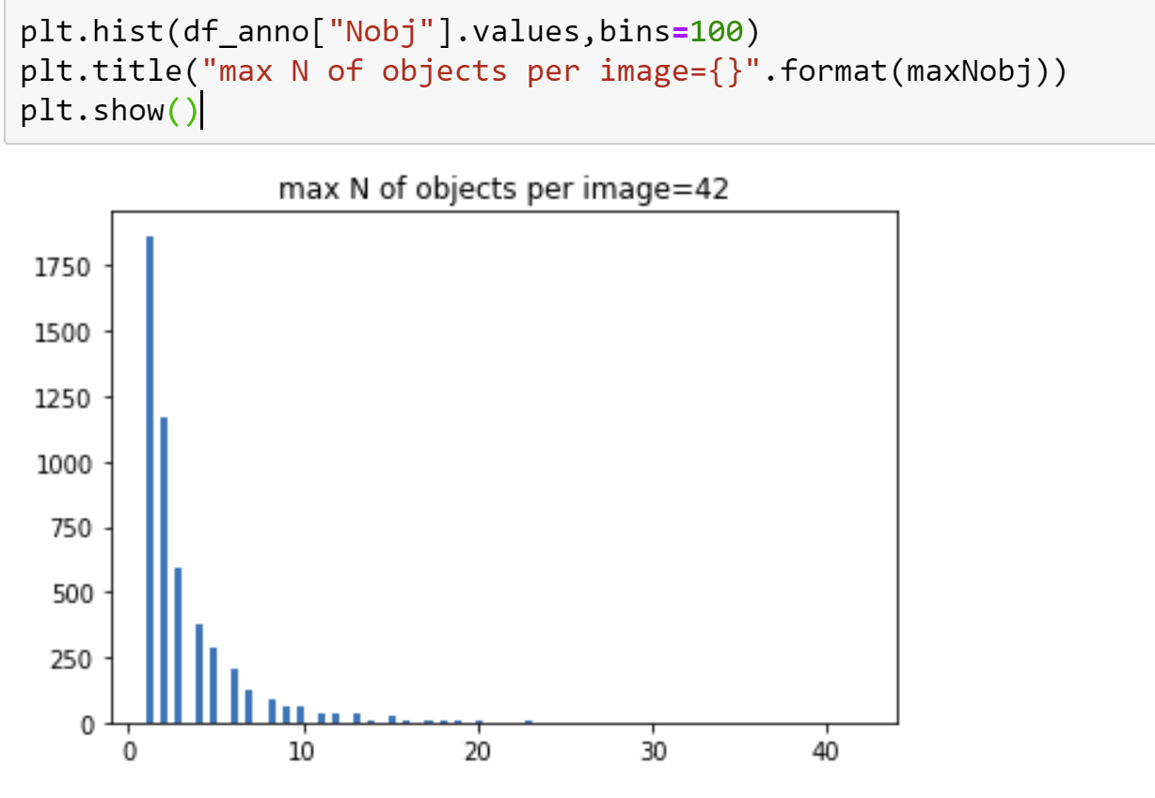

Displaying the bar plot of objects vs class on the entire dataset. There are total 20 different classes in the dataset.

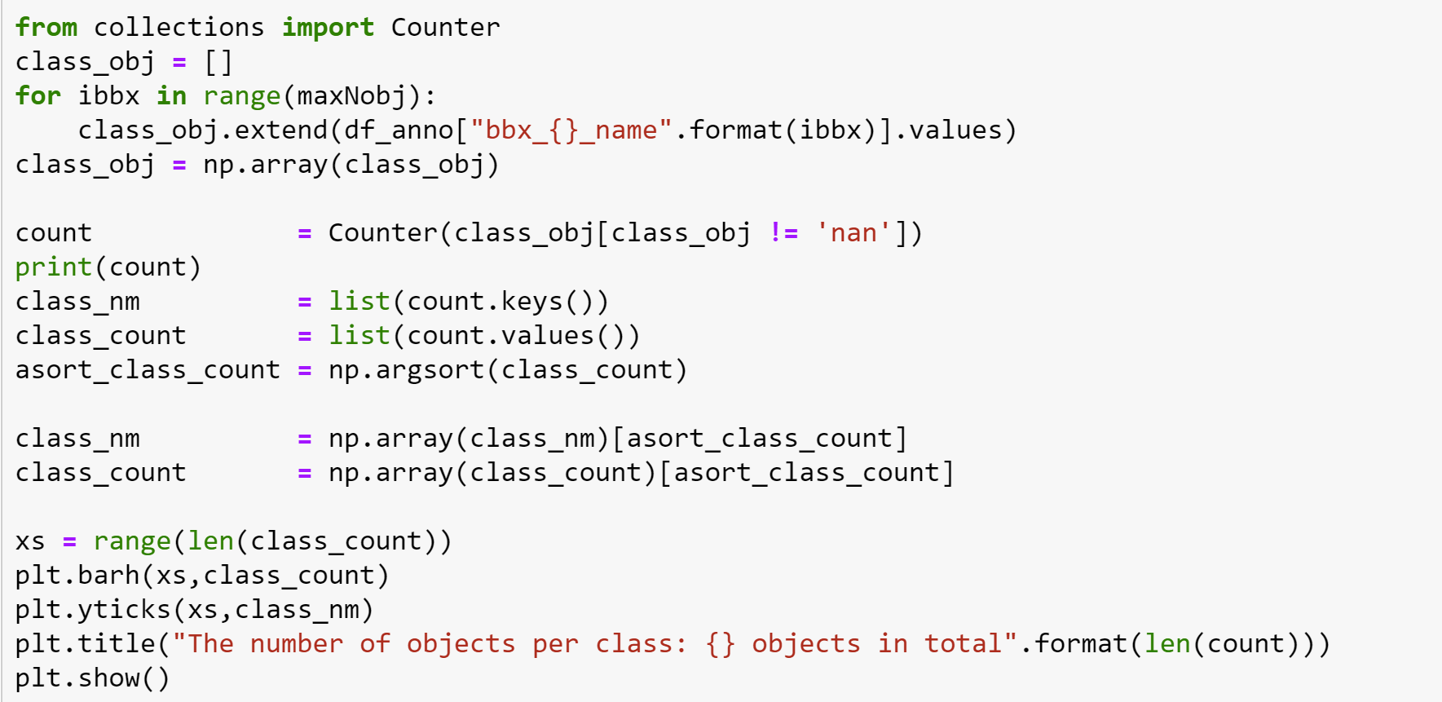

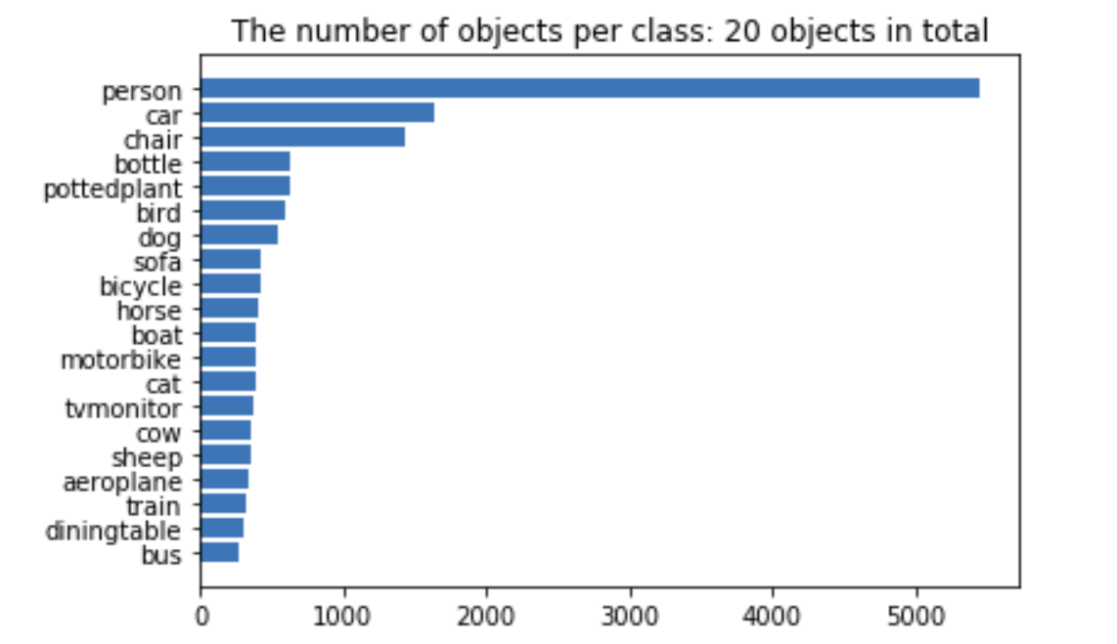

6. object detection:

Displaying few images with boundary boxes and labels

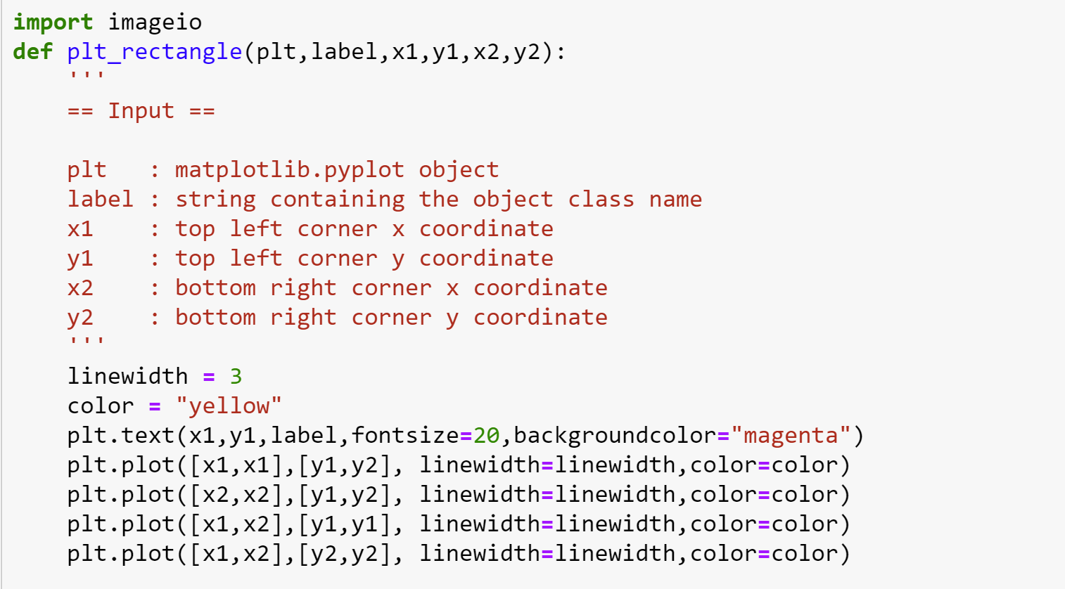

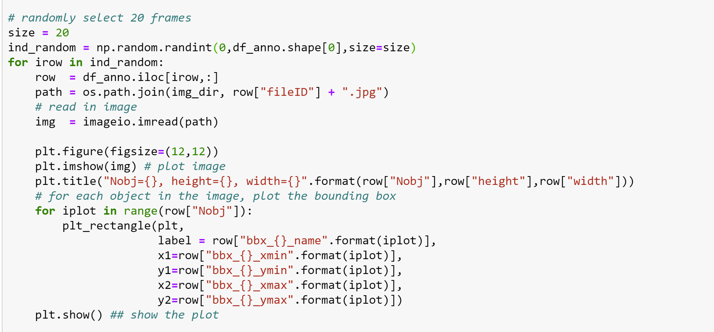

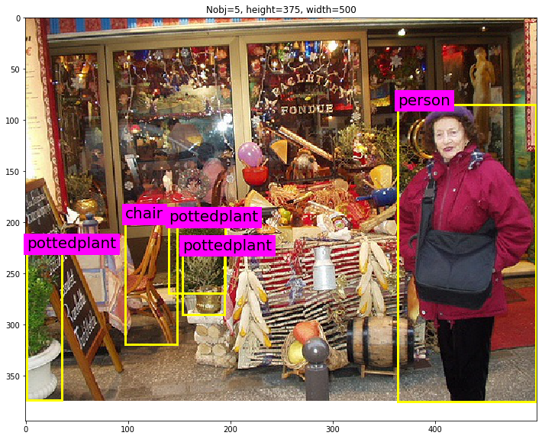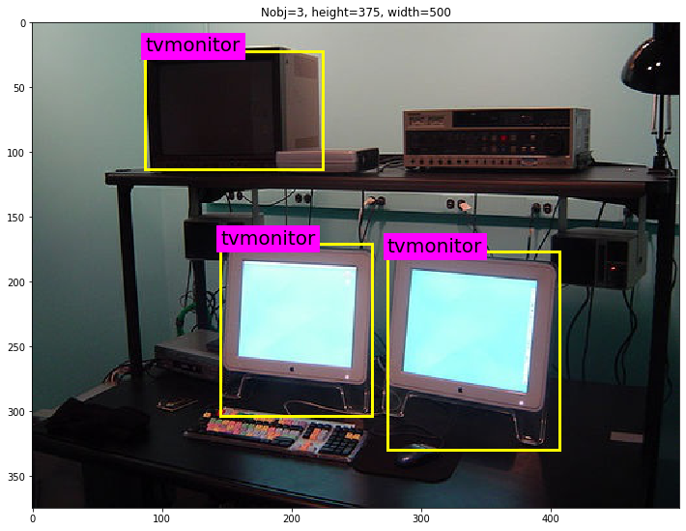

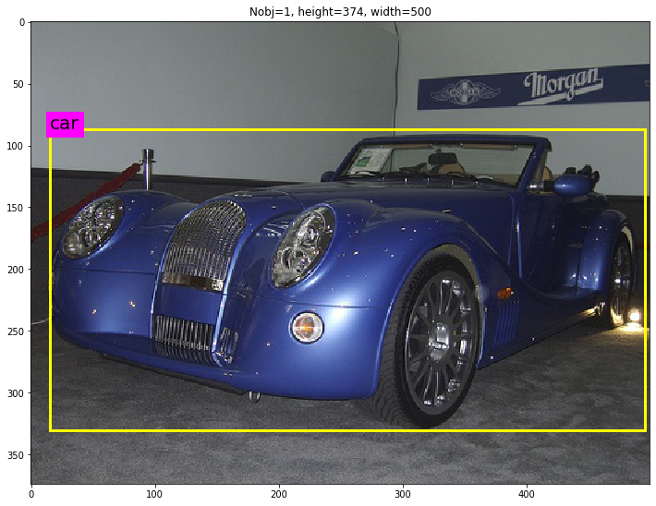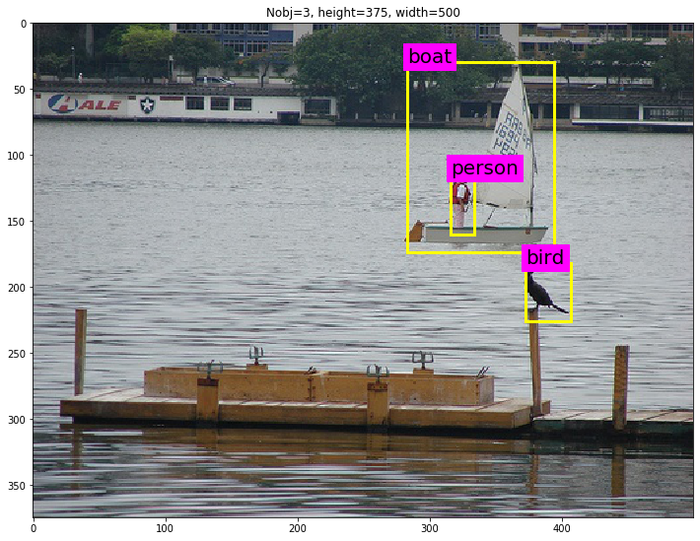

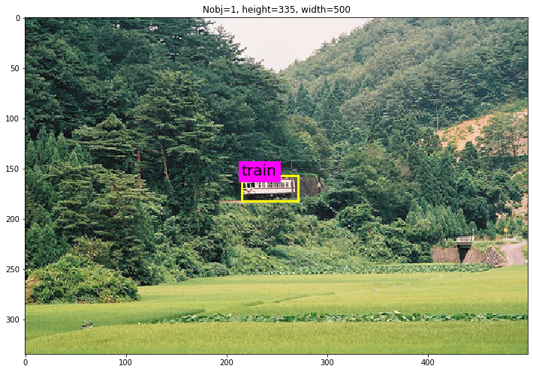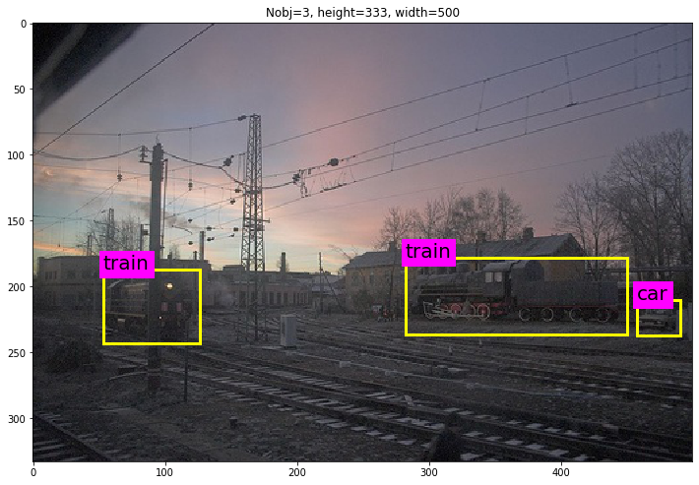

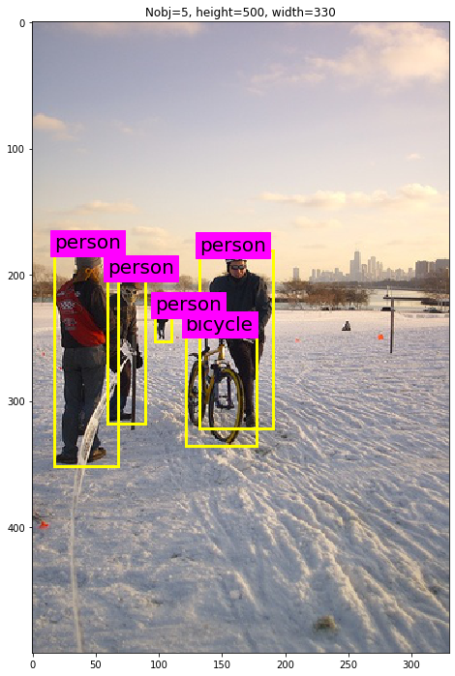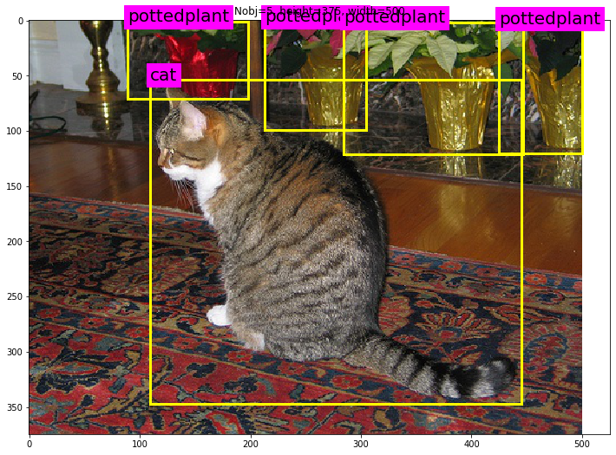

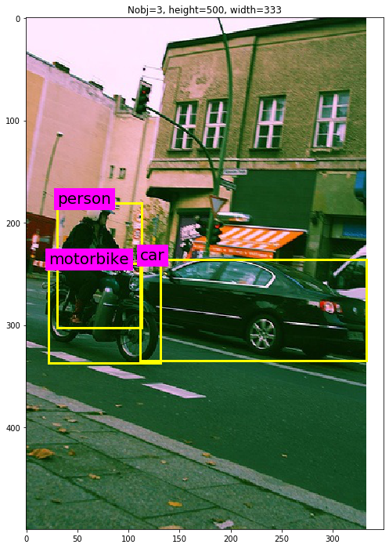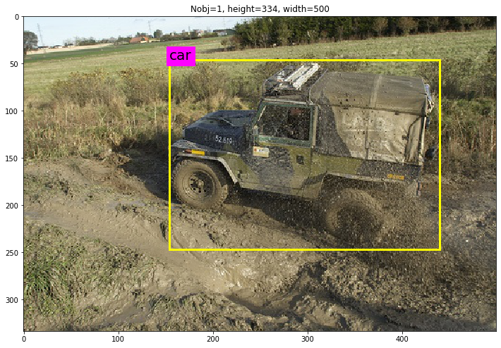

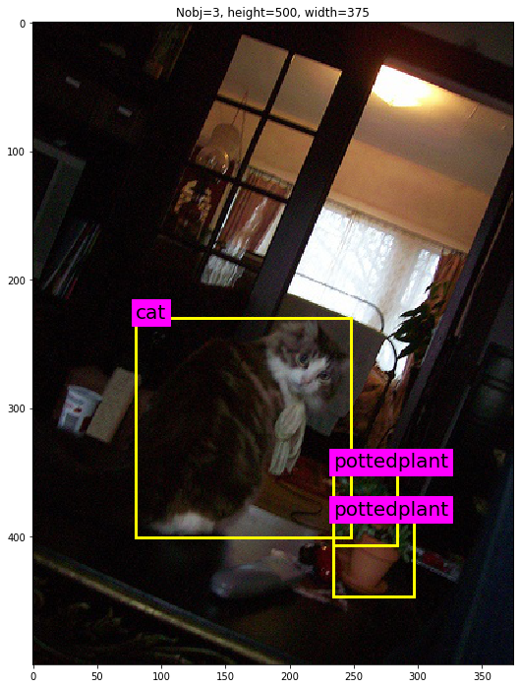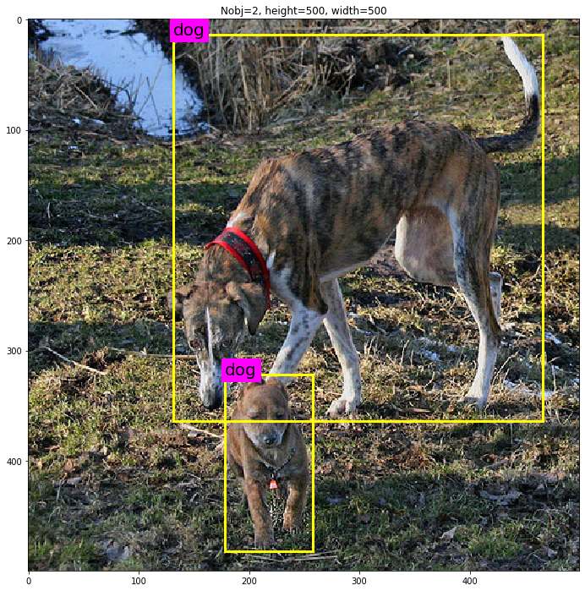

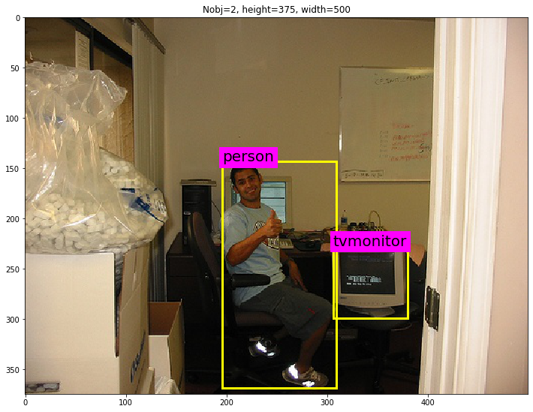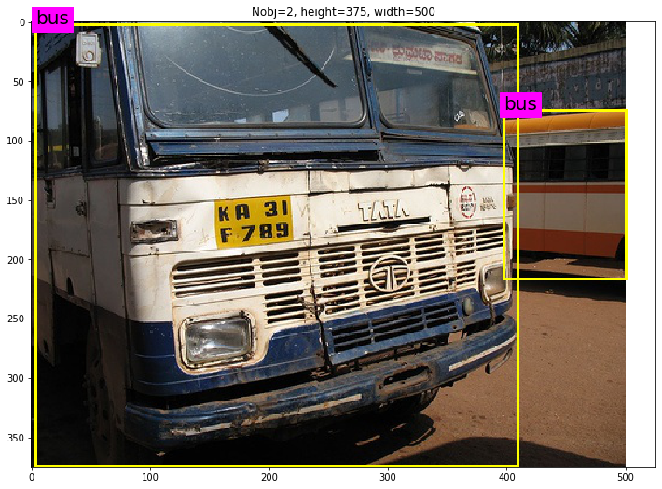

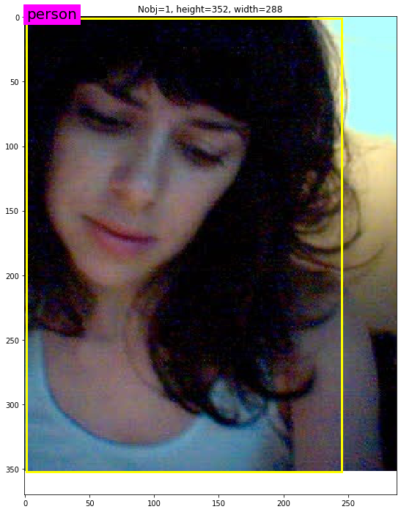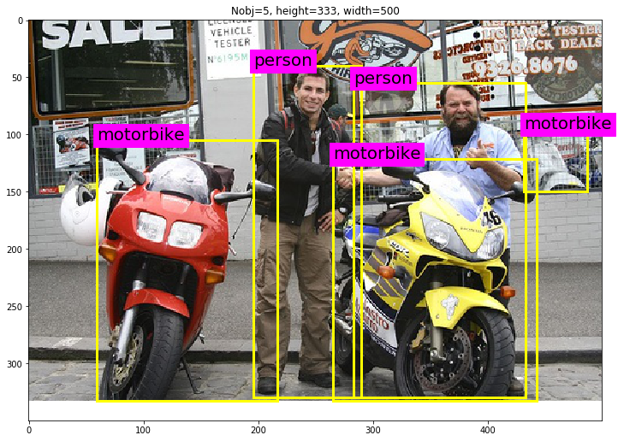

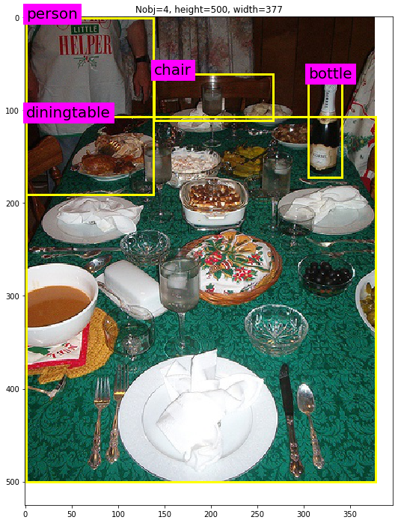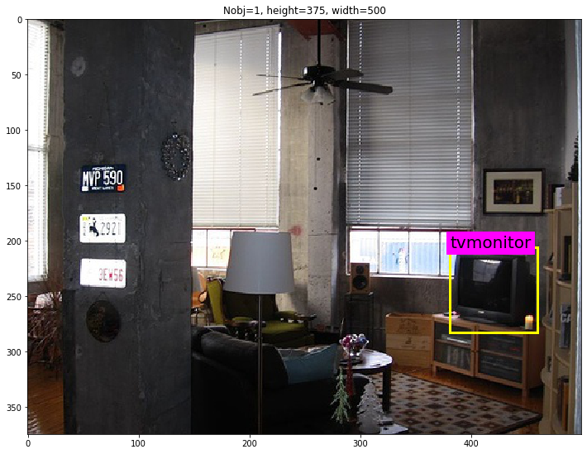

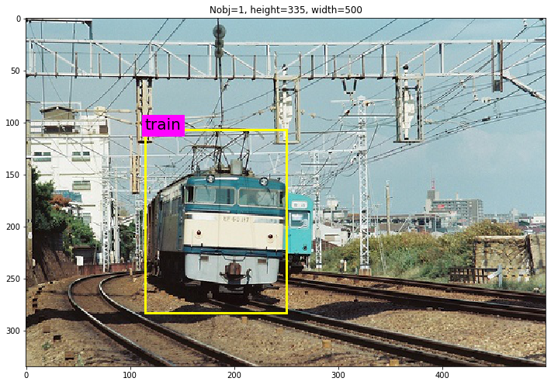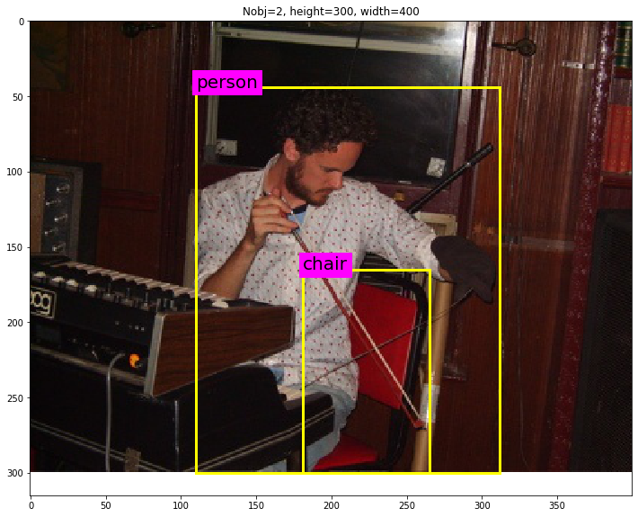

We can observe that the image shape differs across images and few bounding boxes are on top of each other.

7. Semantic/image segmentation:

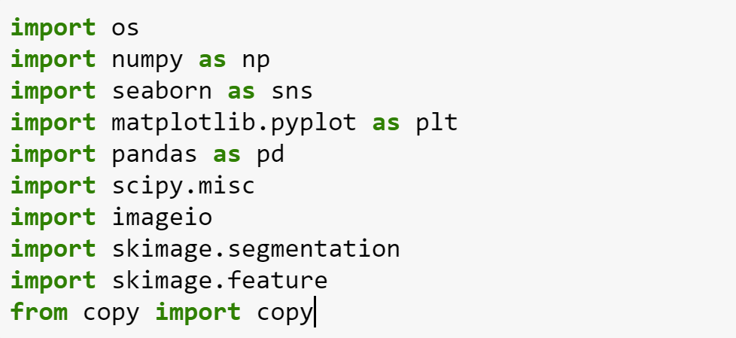

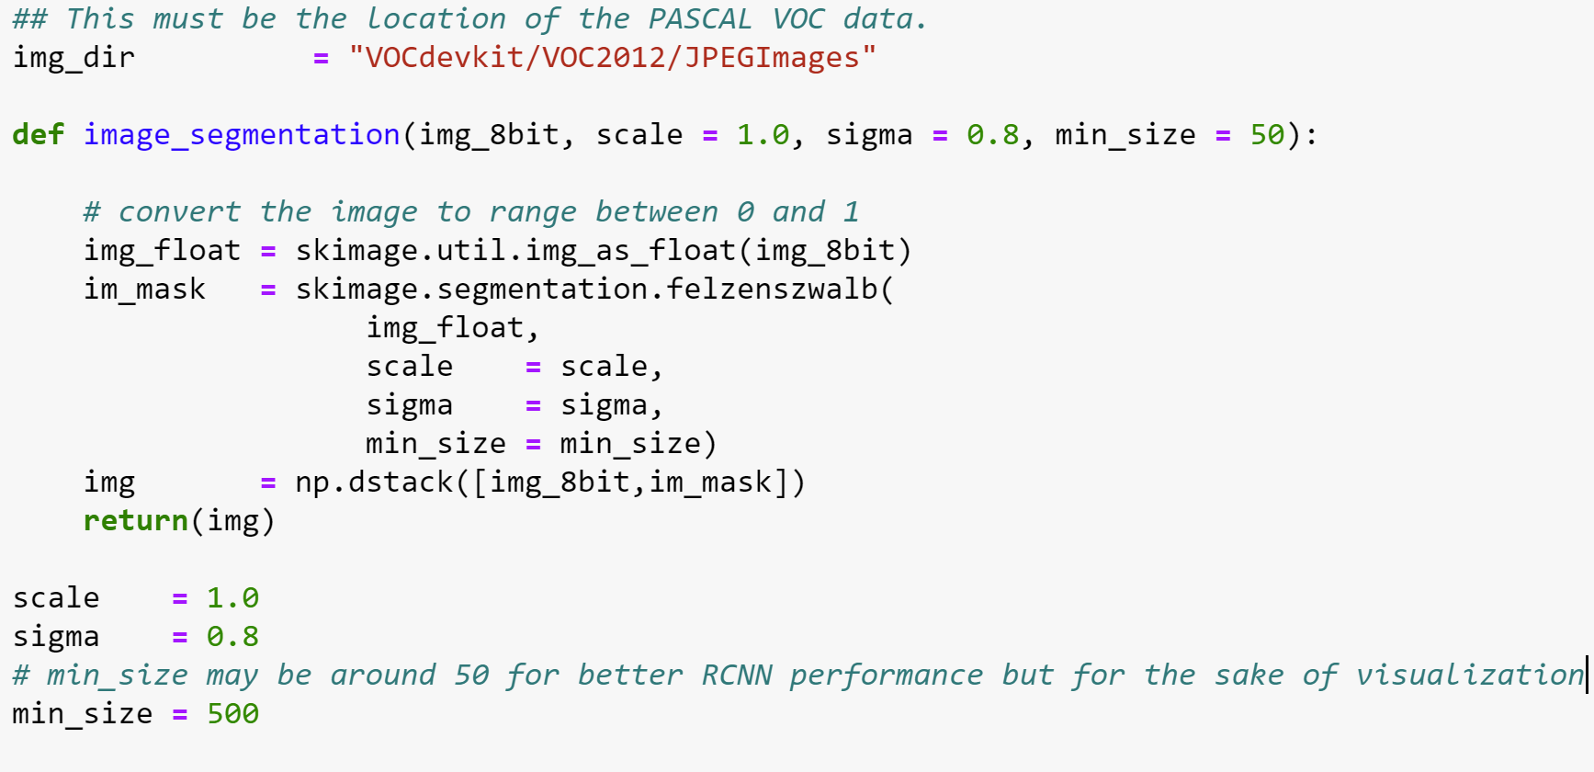

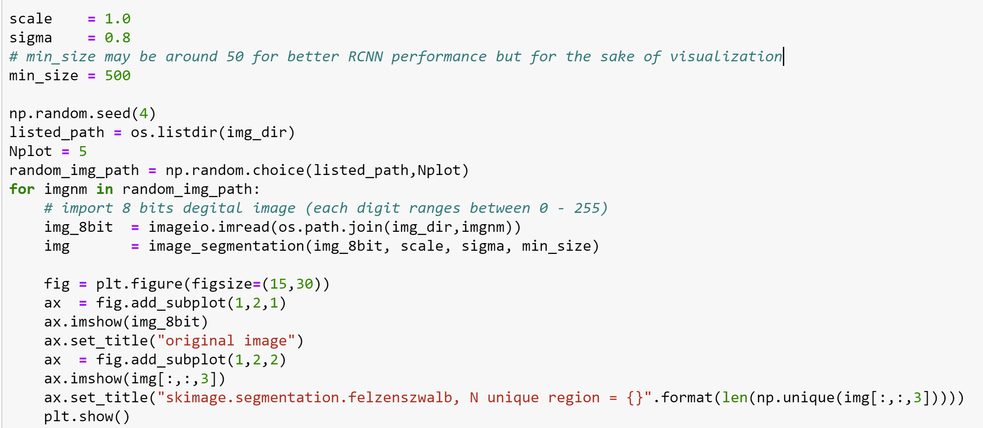

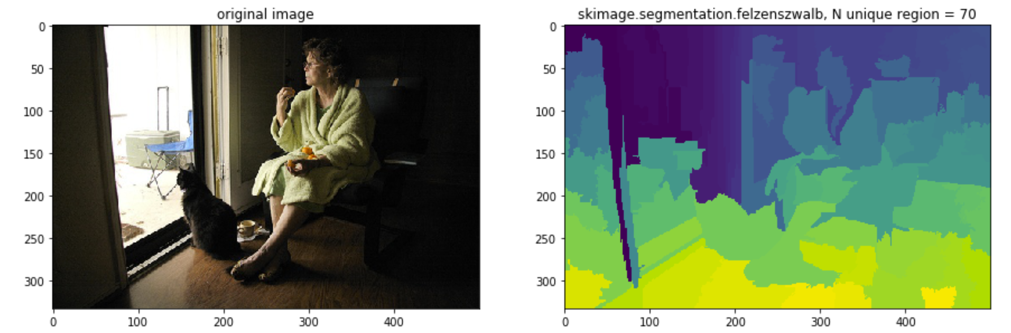

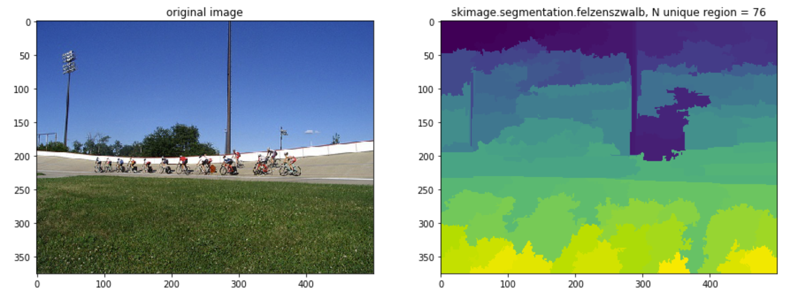

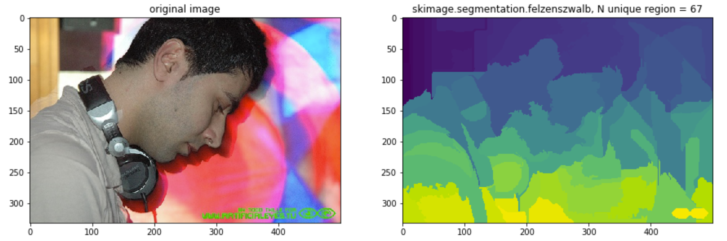

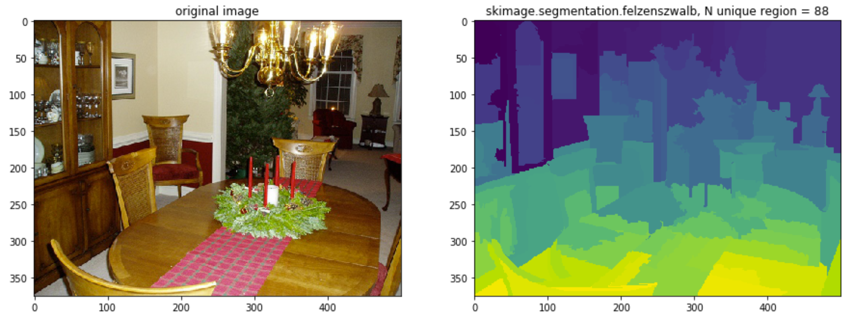

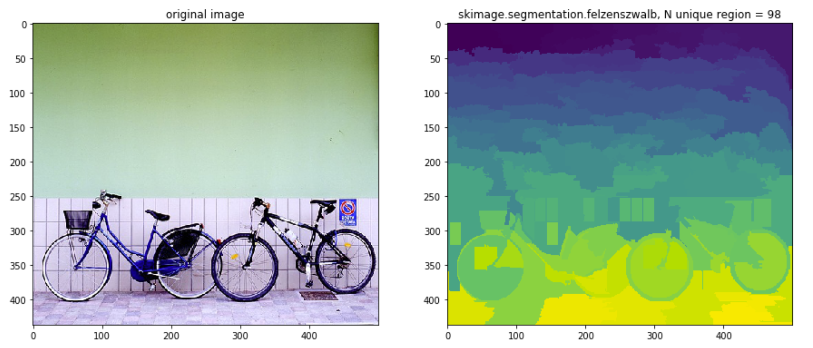

8. Region extraction:

Extract as many rectangle regions as the number of the regions found by the segmentation algorithm. Each rectangle region is selected to be the smallest rectangle region covering the entire segmented region.

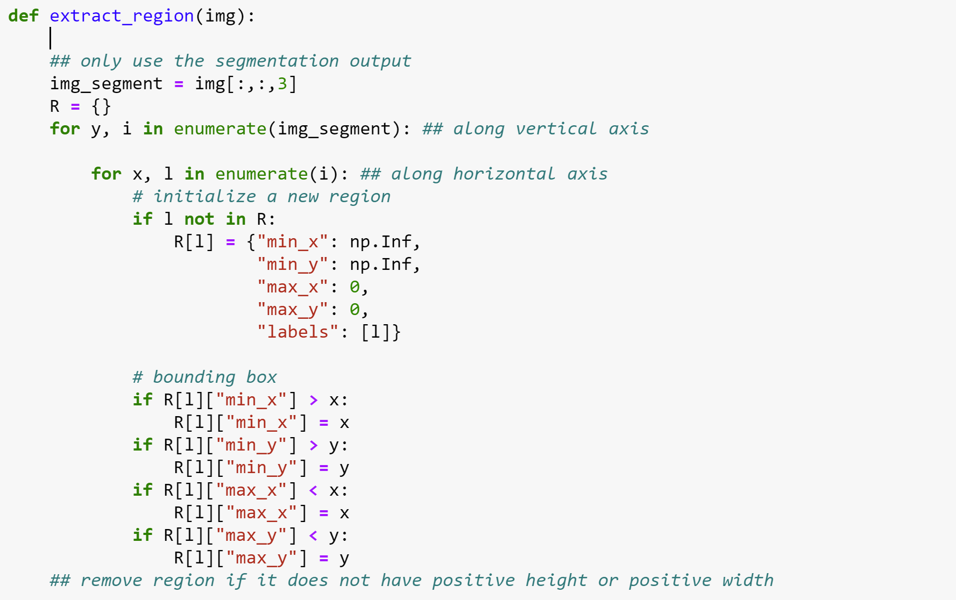

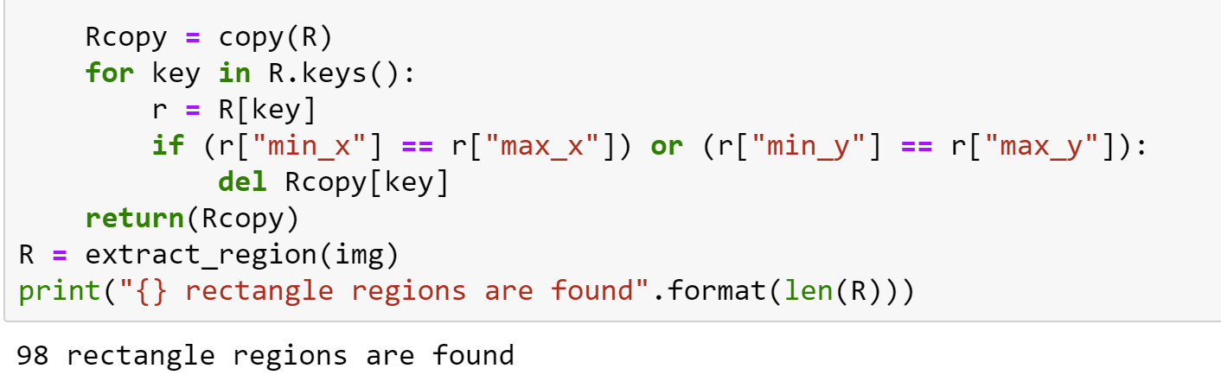

9. visualizing rectangular regions

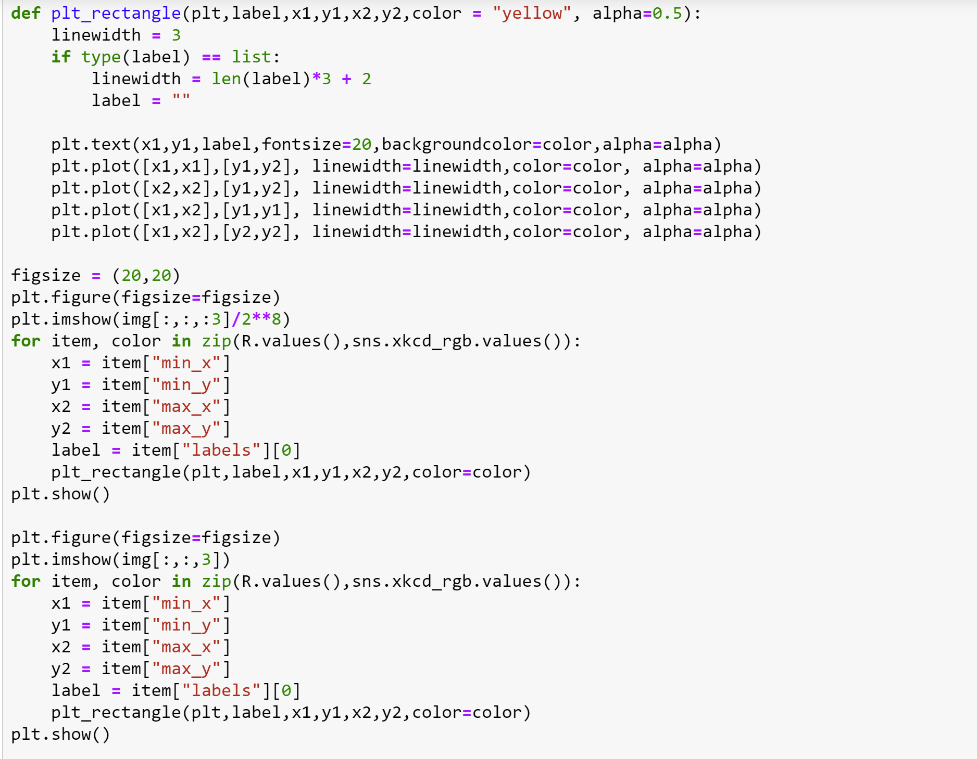

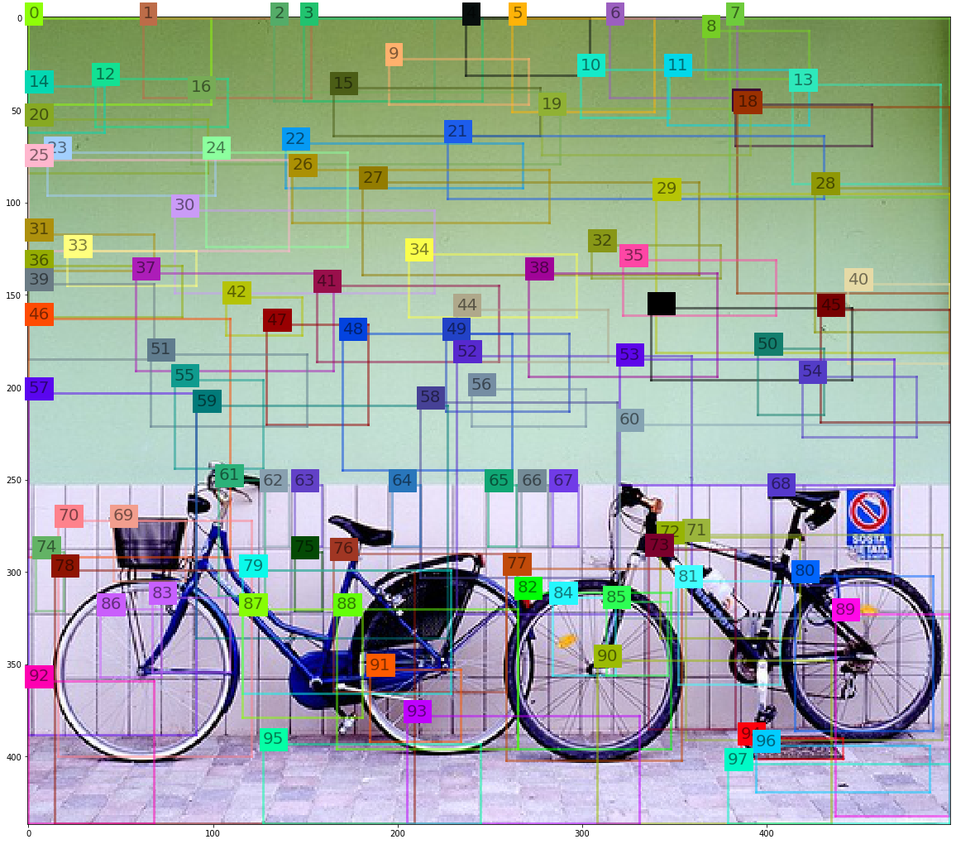

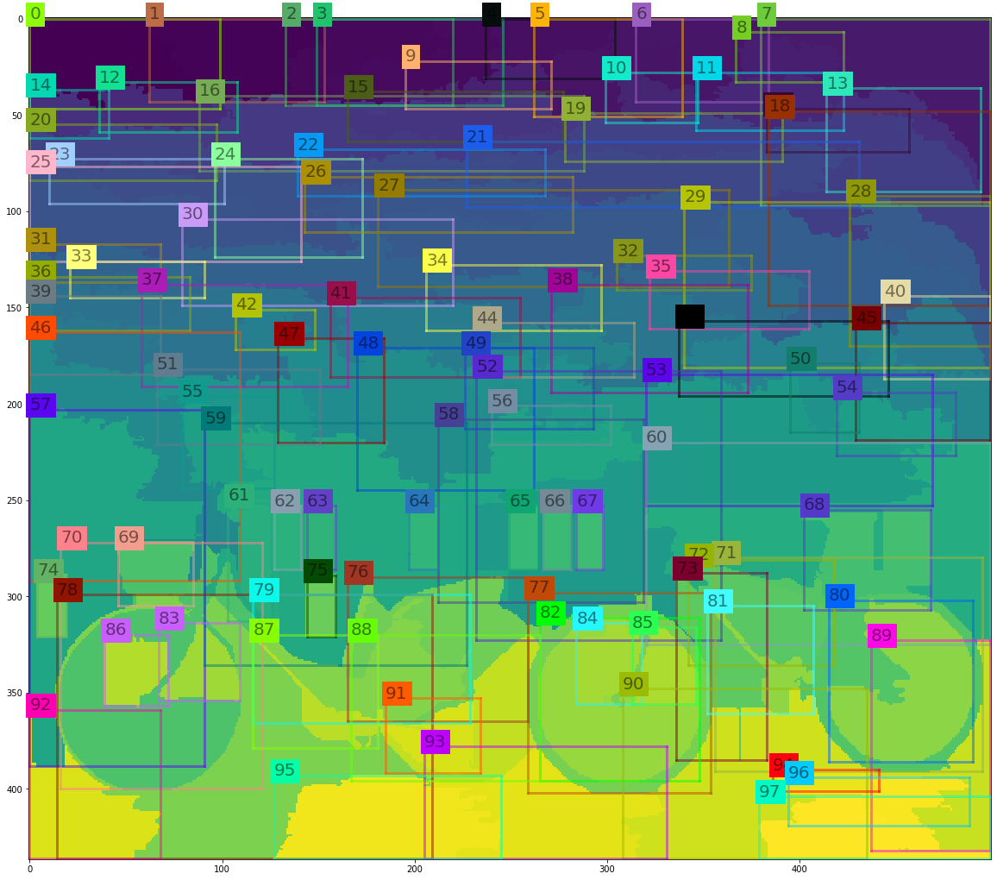

Grouping the regions based on using Local Binary Pattern (LBP) texture operator,

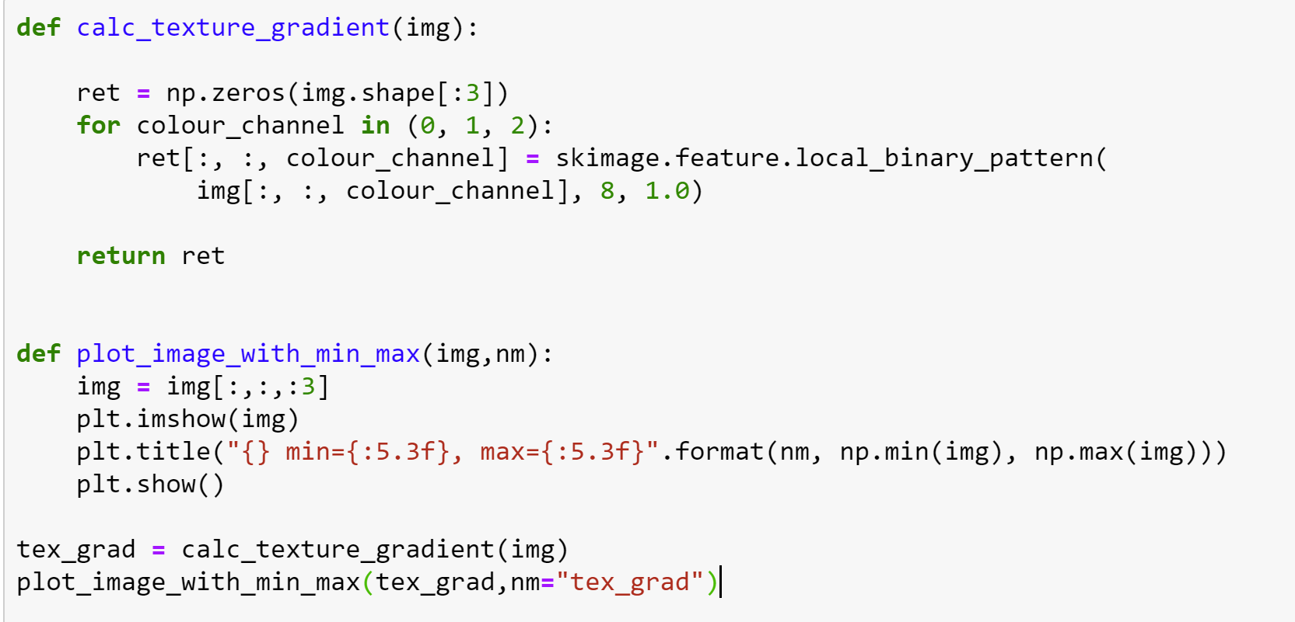

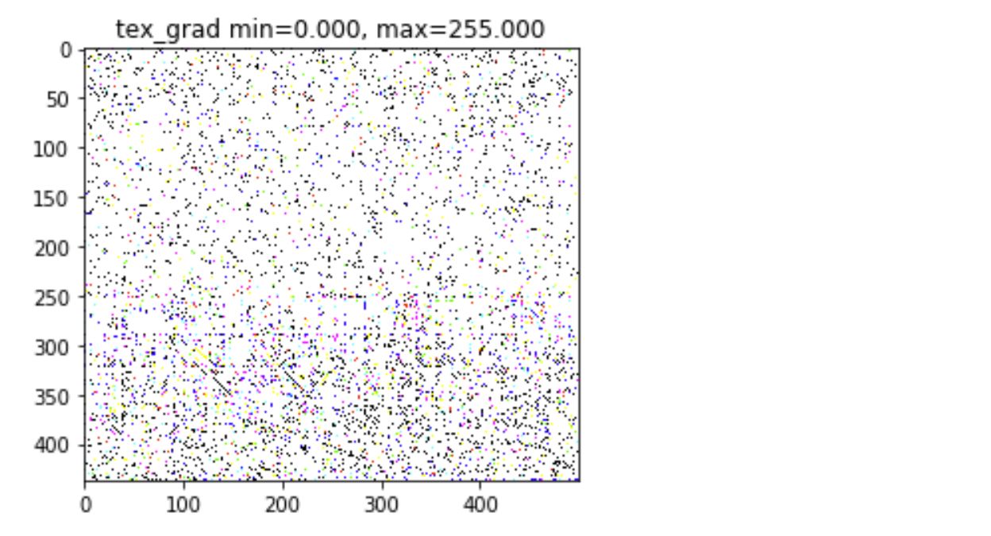

So far we saw image representation in RGB. Here, we display Image using HSV color space.

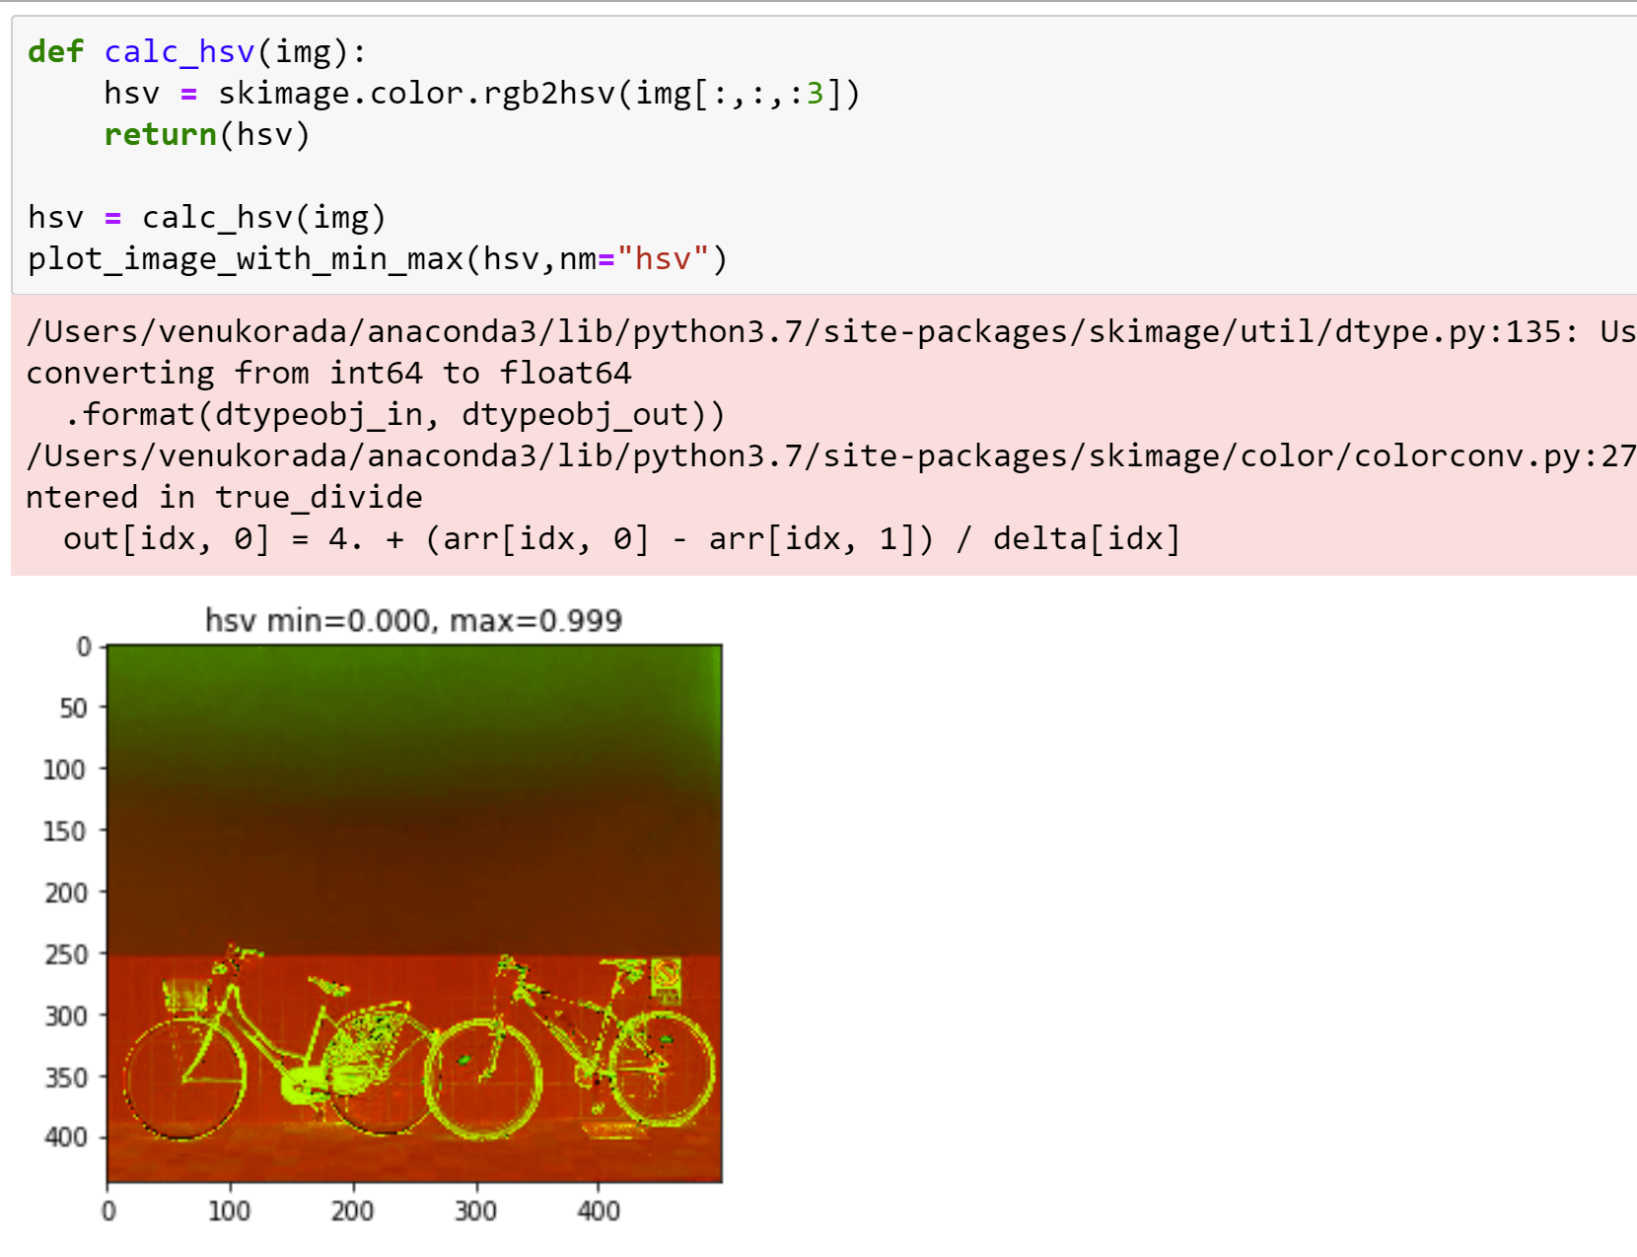

CNN feature extraction using keras built in model:

Install keras and tenserflow libraries.

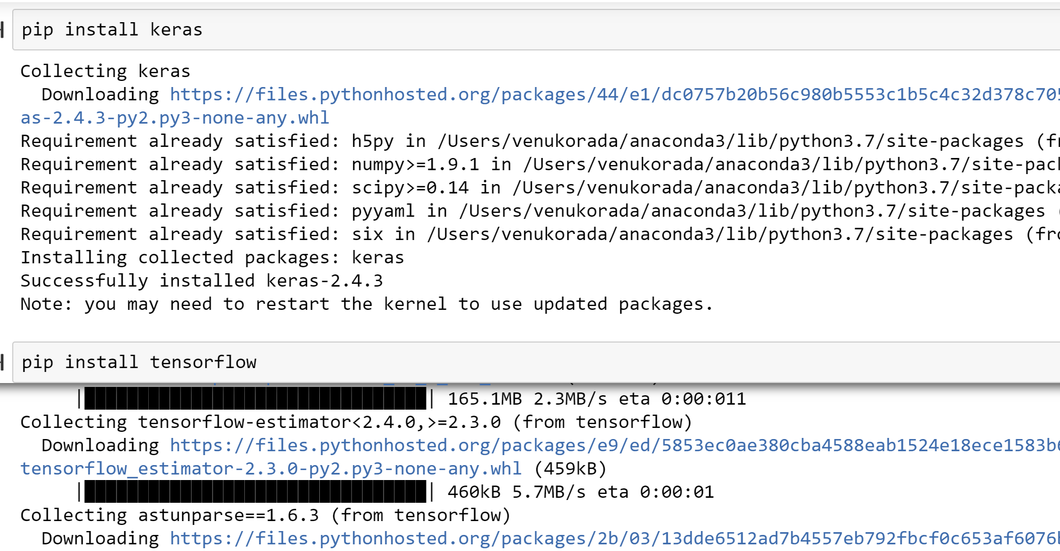

VGGNet is a built-in tensor flow model for extracting features from images.

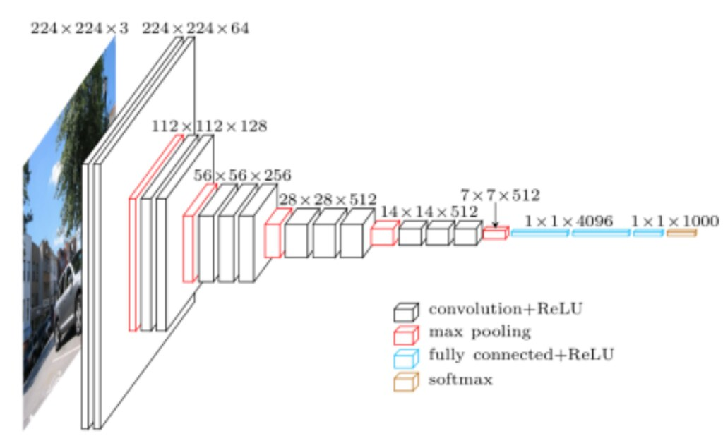

VGGNet has a many filter as seen in the model architecture above. It contains 16 layers with trainable weights.

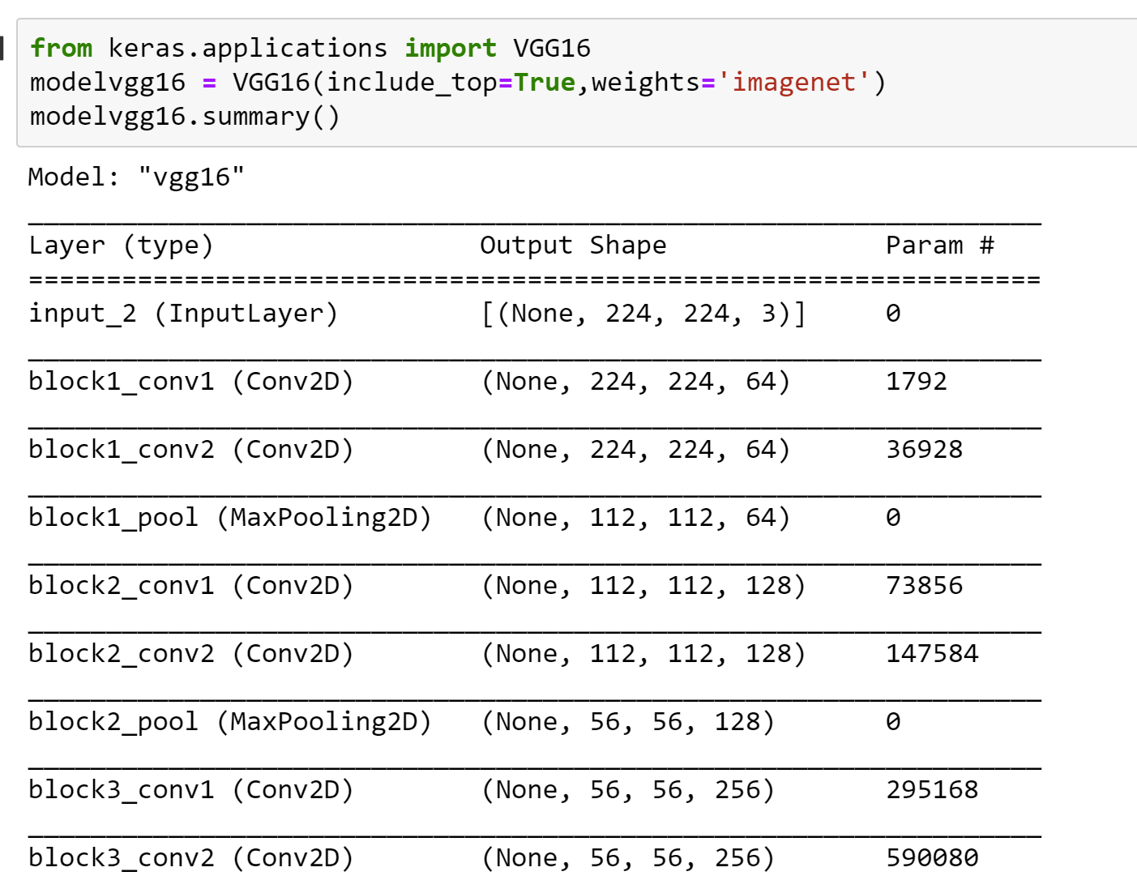

We are using VGGNet not just for classification but also for feature extraction.

While trying to apply DAG for VOC12 we are ending up with computational complexities resulting in out of index errors along with gpu being hung. So, for computational ease we are performing FGSM attack on MNIST dataset.

As we have taken 2nd paper as DAPAS (Denoising Autoencoder to Prevent Adversarial attack in Semantic Segmentation), we will be implementing FGSM attack on MNIST and then use the denoising auto encoder to clean the images from the attack.

FGSM Attack:

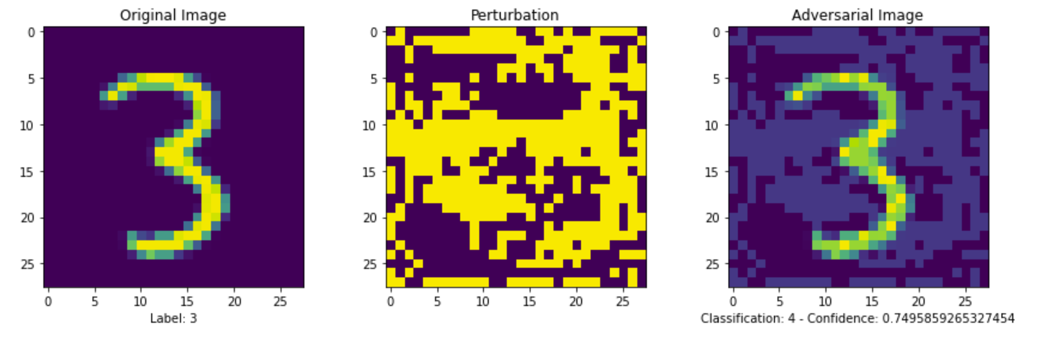

DAPAS defense:

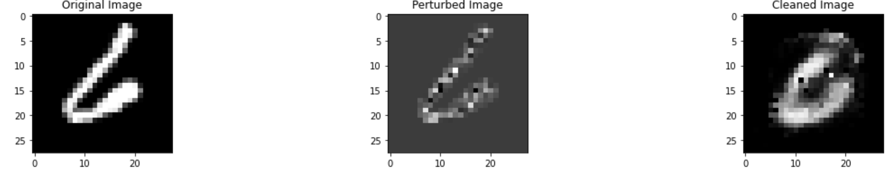

FGSM Attack:

Installing tensorflow

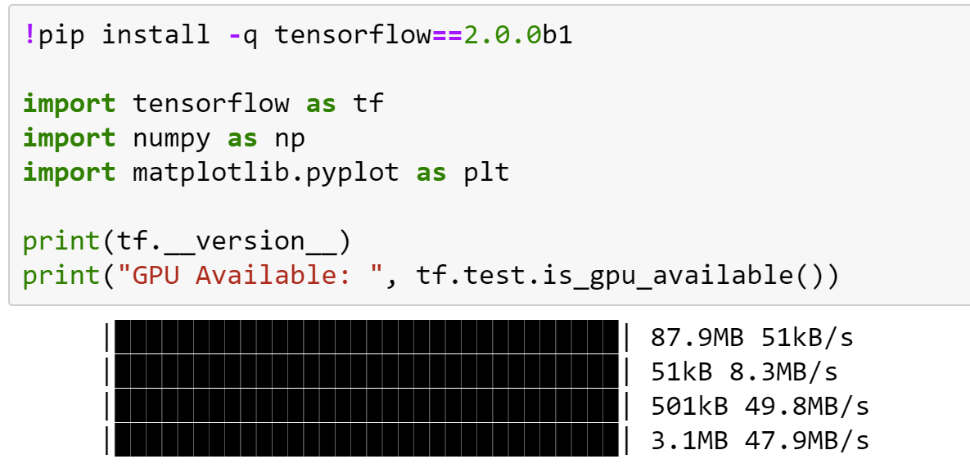

Loading MNIST dataset from Keras and building keras model with 4 layers, Adam optimizer and cross entropy loss

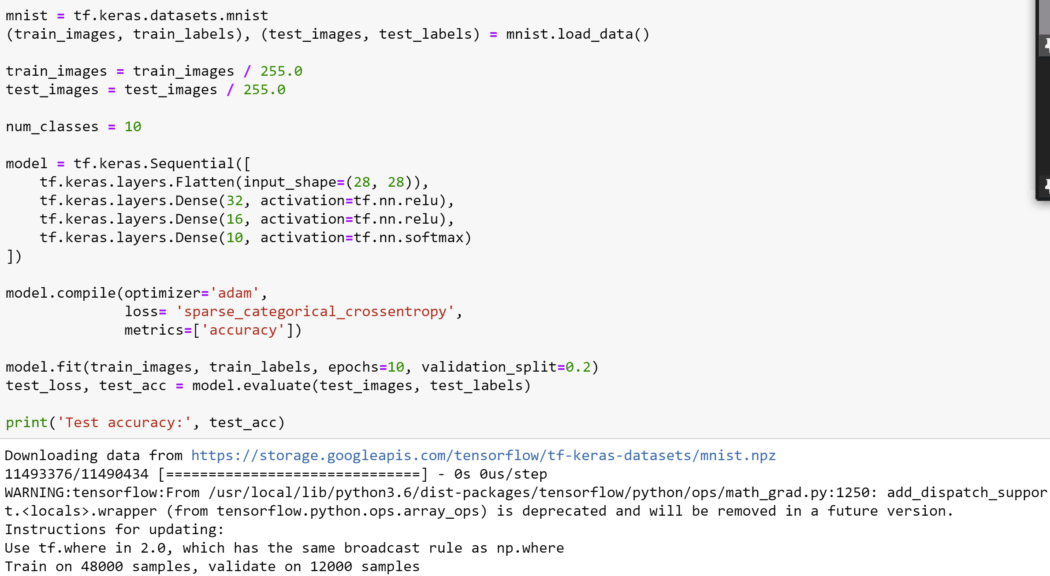

pick a random image from the training set and convert its corresponding label into its one-hot encoded version. 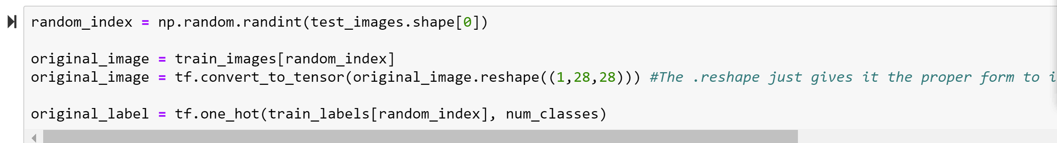

image display,

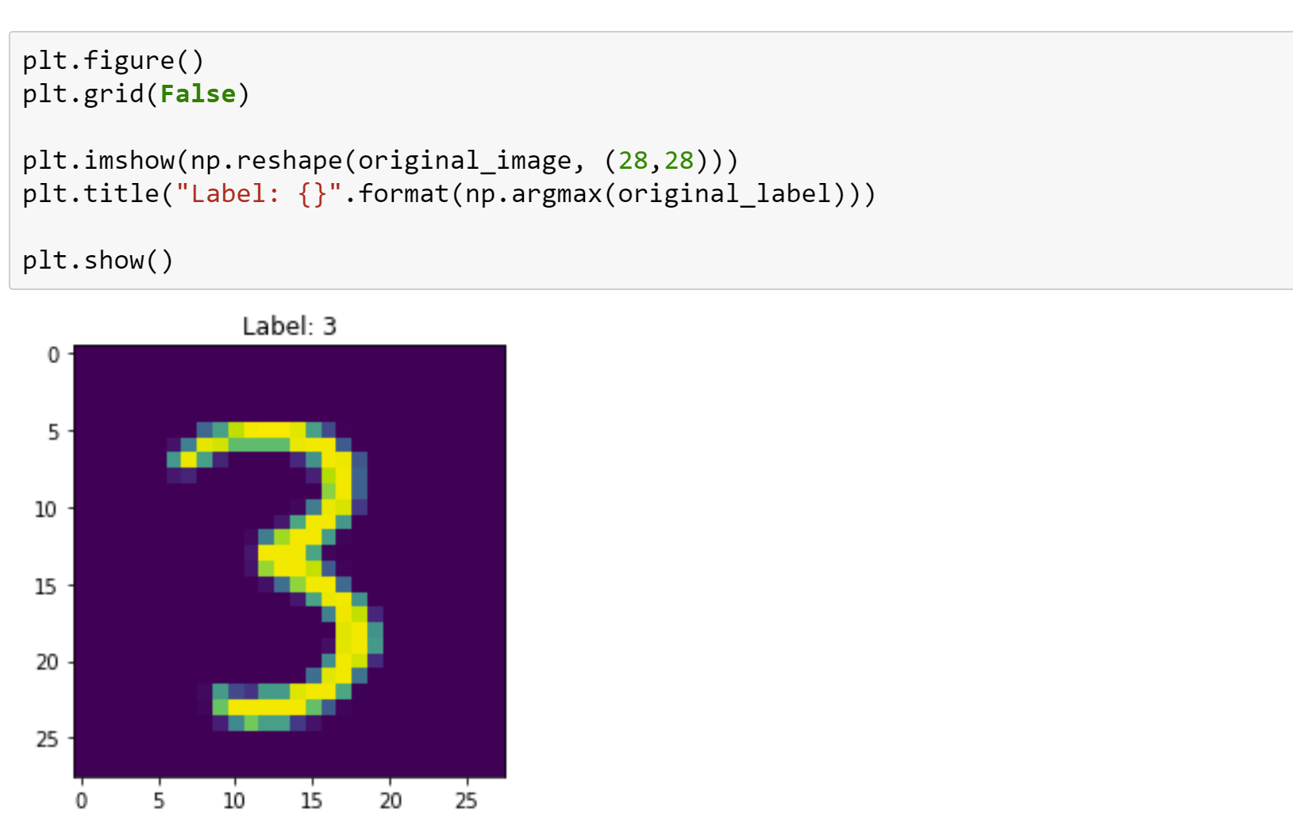

Function to create perturbation

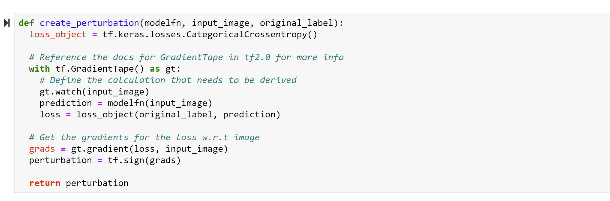

Applying perturbation on the model,

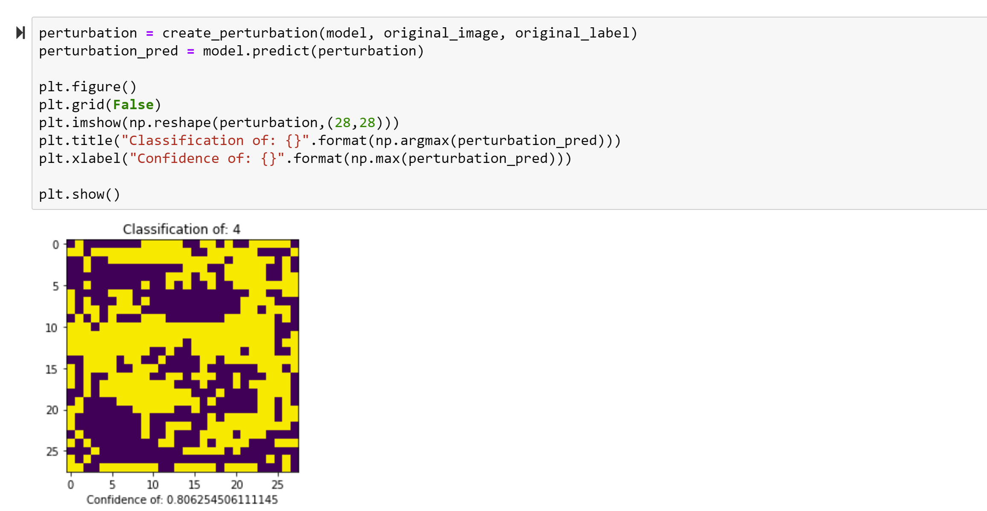

function for fgsm,

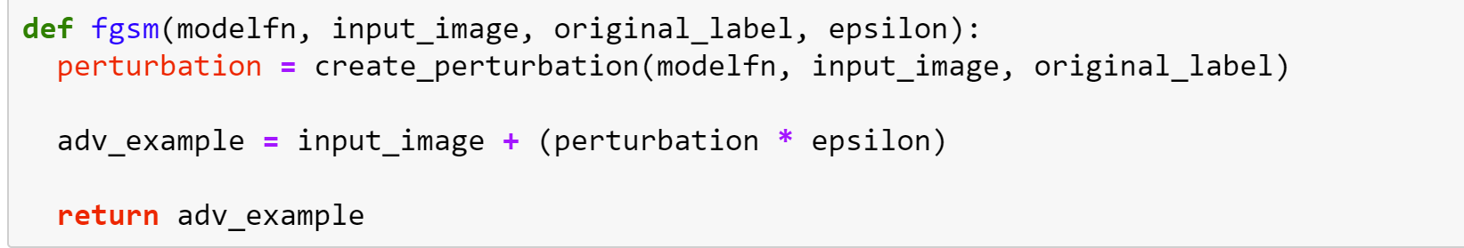

Creating the adversal image with epsilon 1

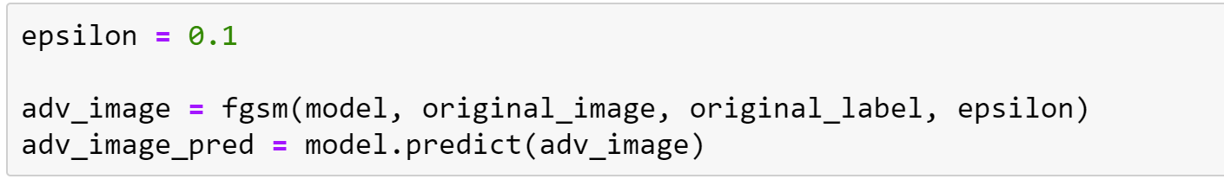

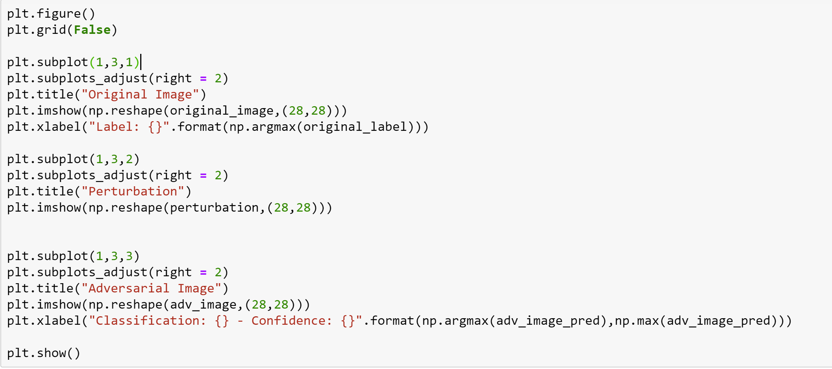

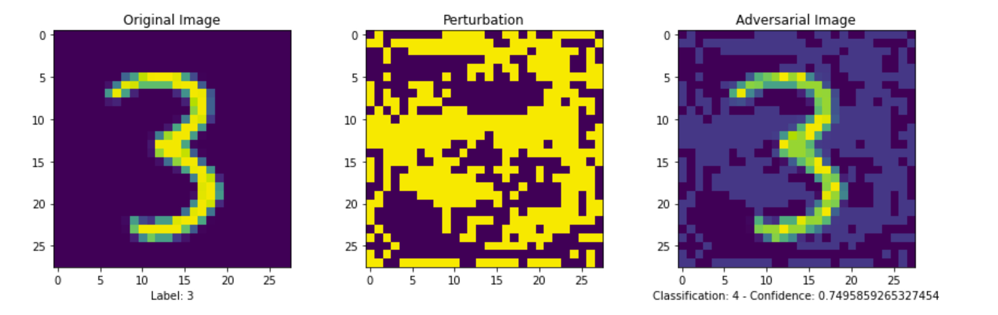

Initially original image is classified the image as “3” but after adding the perturbation the model classified the image as “4” with confidence 74.9%

Training the model with epsilon = 0.01,

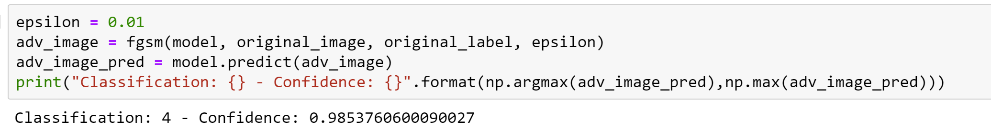

Now, original image 3 is again classified as 4 with increased confidence of 98%.

Now, run the model 100 times to observe the above classification,

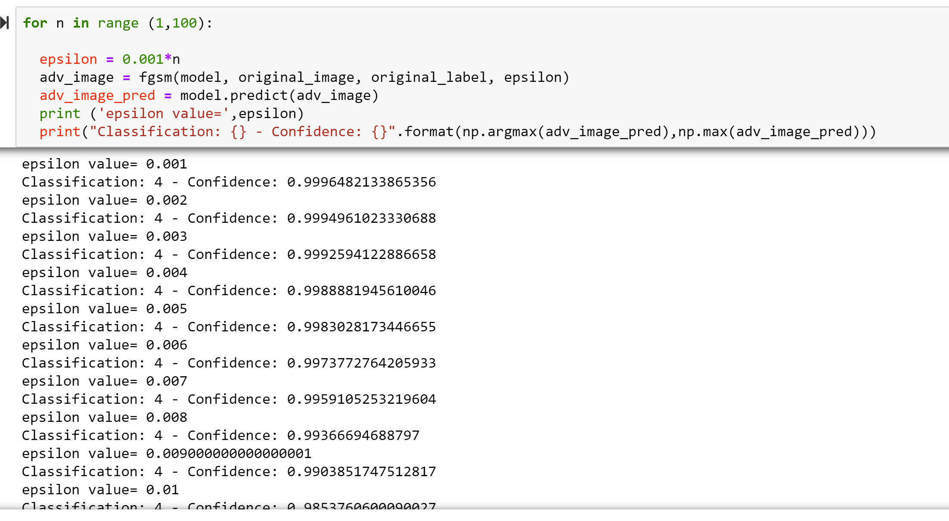

In all the 100 iteration the fgsm applied model misclassified the image “3” to be “4”

**DAPAS:**

Importing libraries,

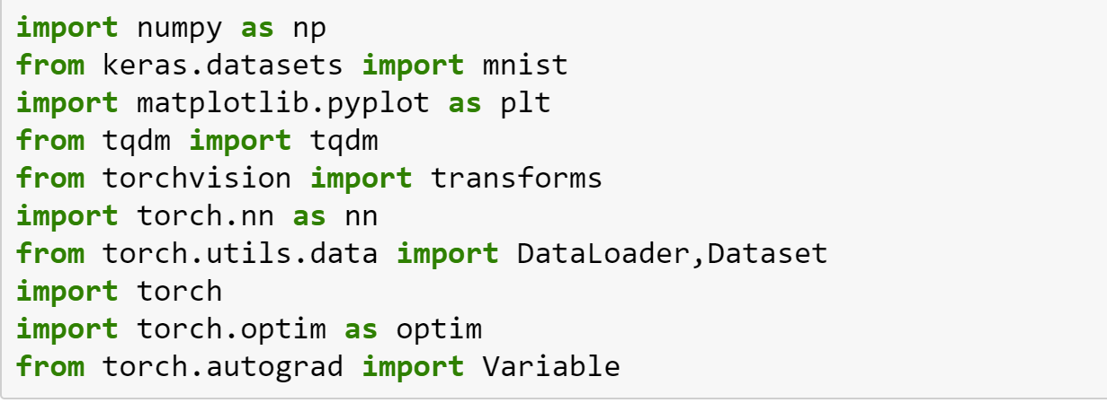

Function to add noise using gaussian and speckle types

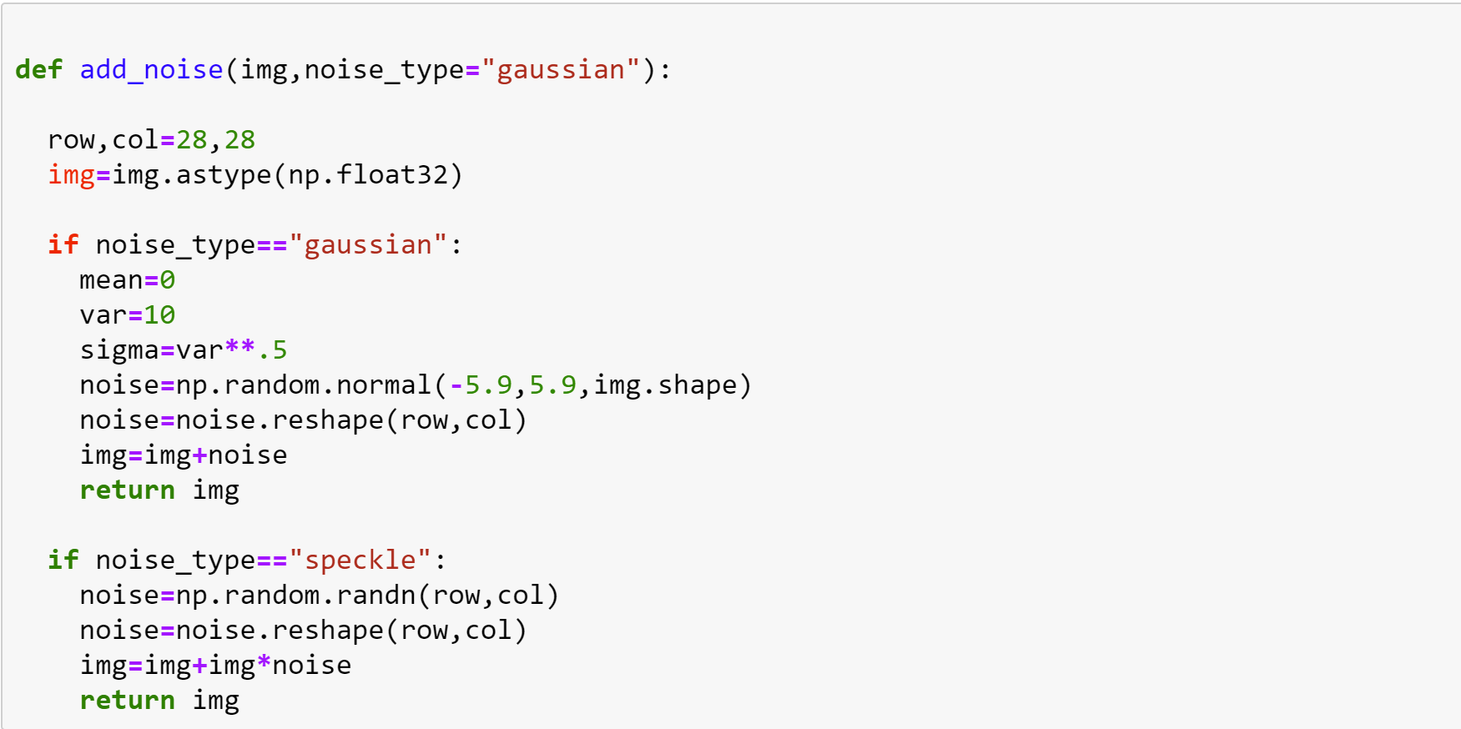

Loading MNIST dataset,

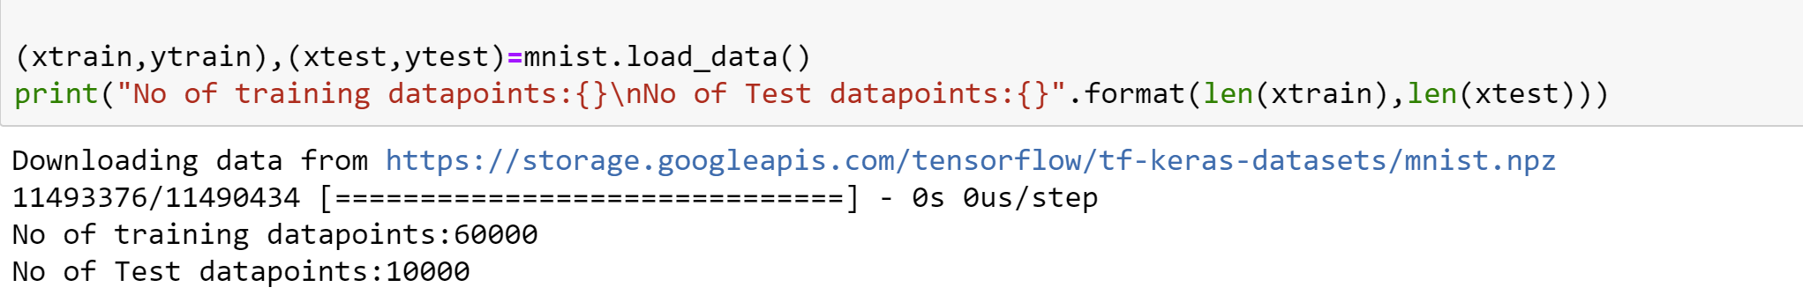

Adding noise,

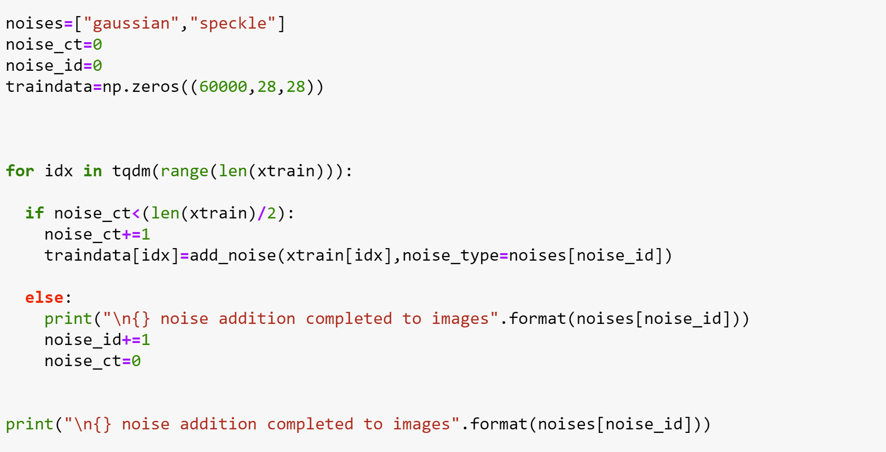

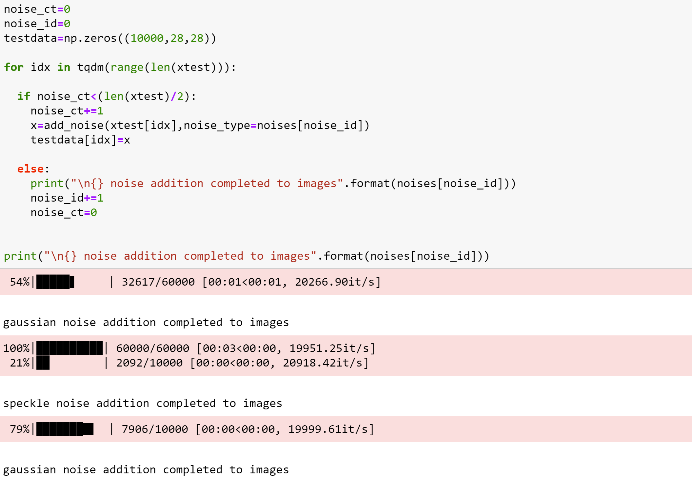

Displaying images before and after adding noise,

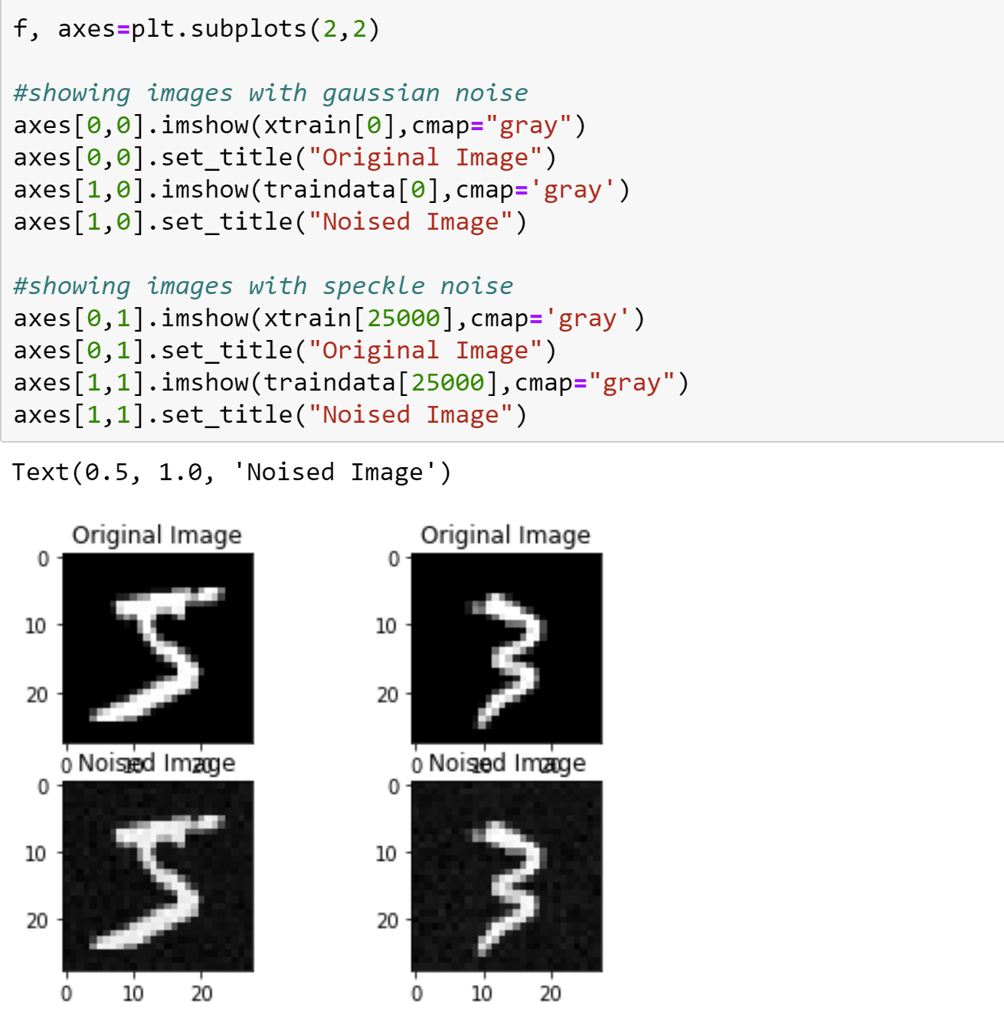

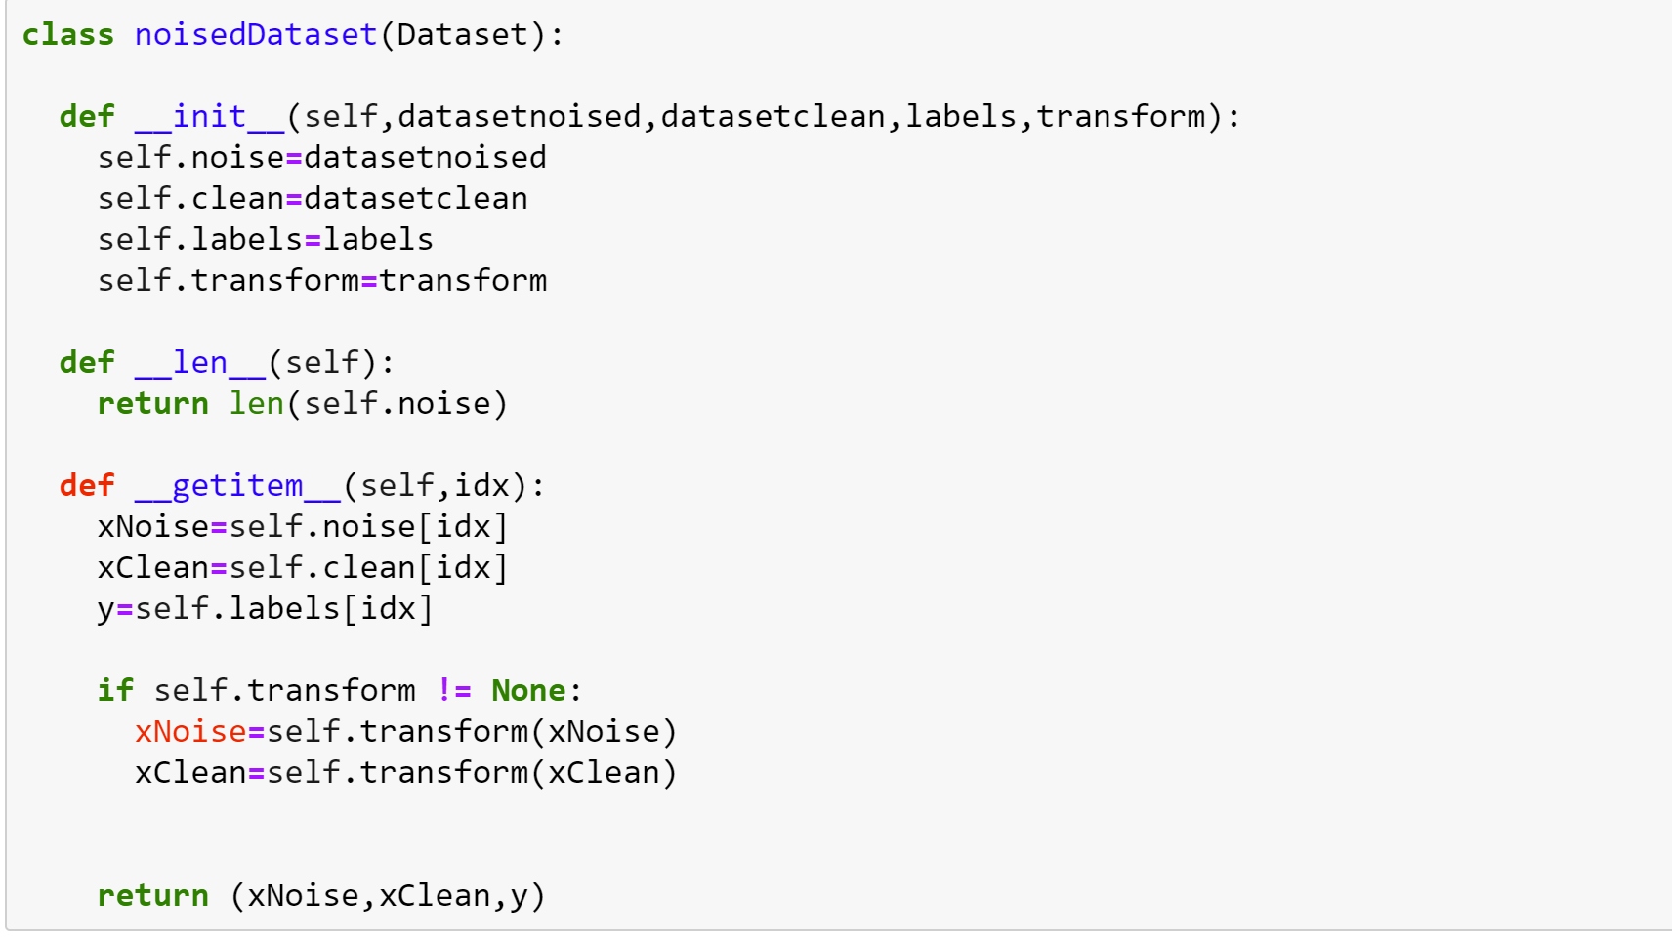

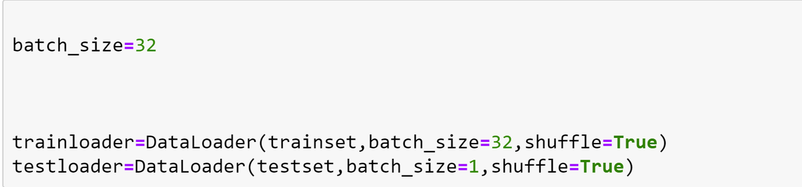

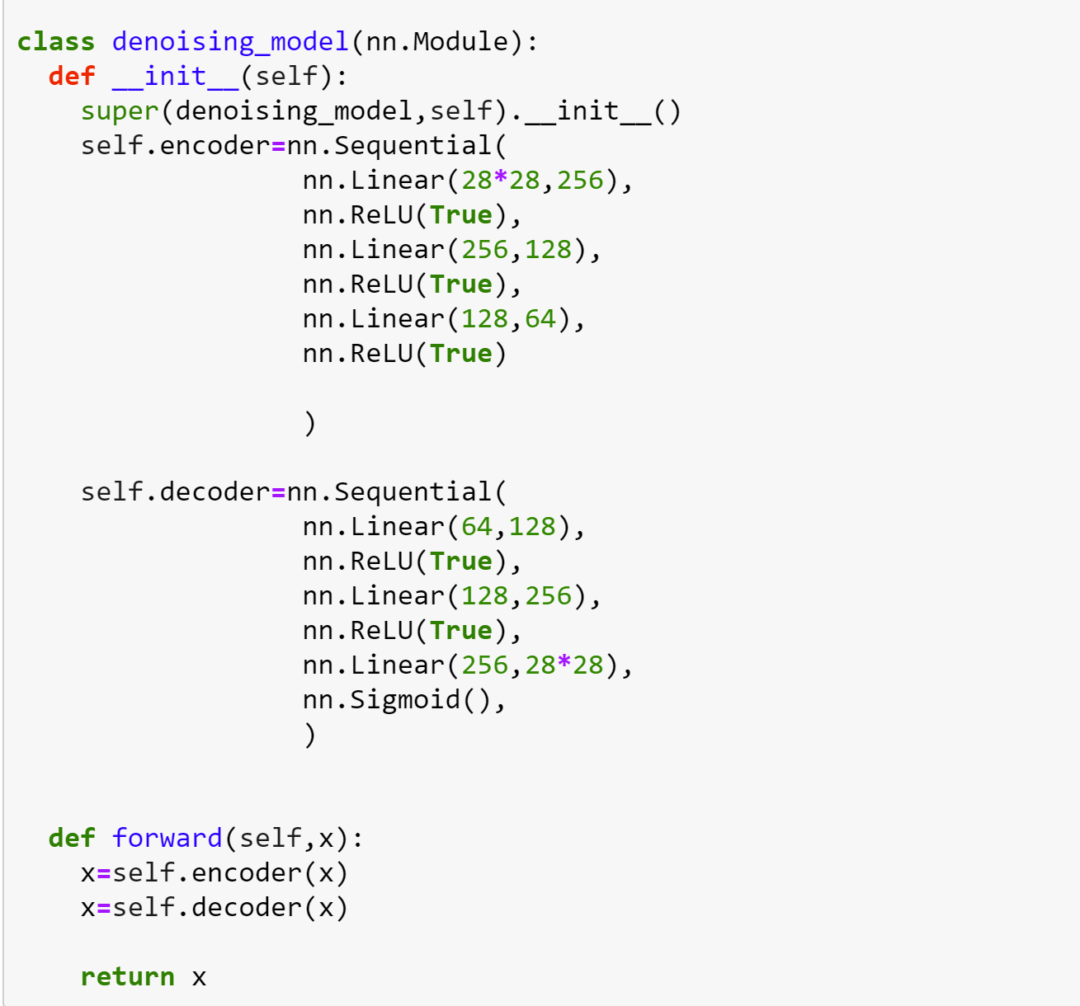

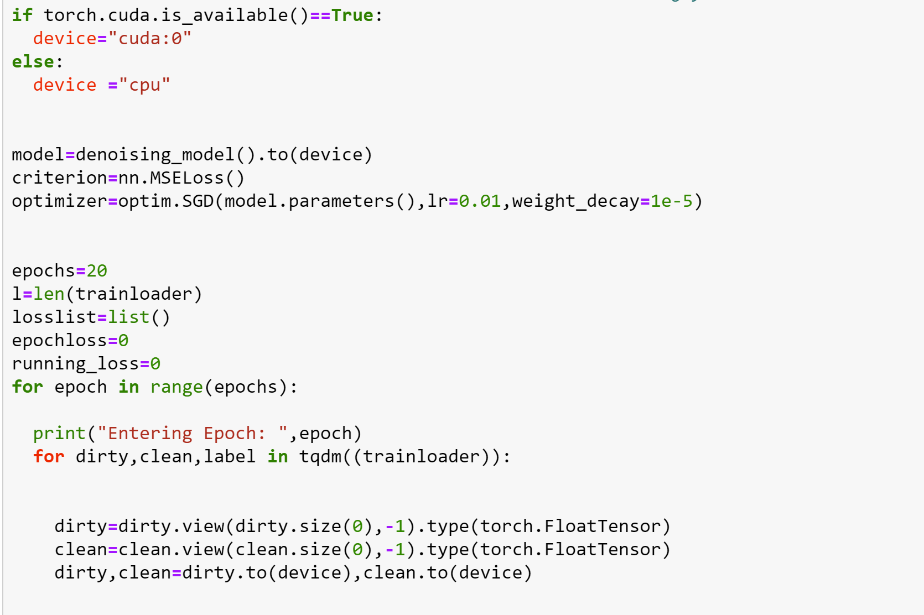

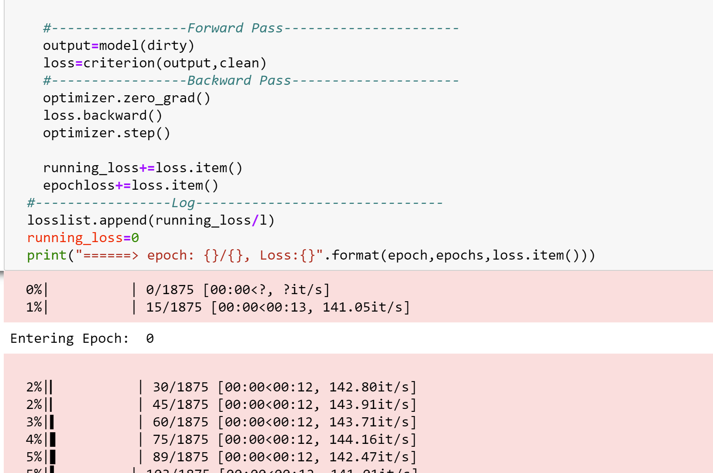

Plot showing the losslist curve,

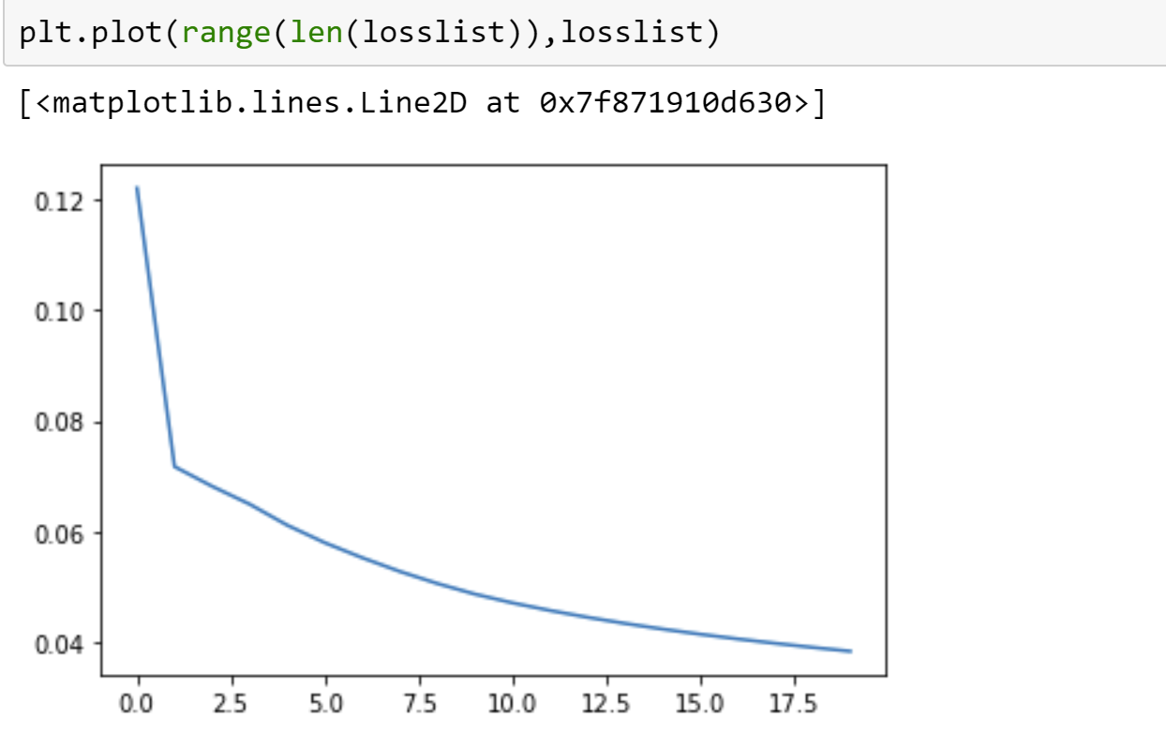

Plotting the original image, perturbed image and cleaned image

